List of figures 3

List of tables 8

Abbreviations 9

Introduction 10

Cancer and Cancer genomics 10

Cancer related genes 12

Types of genomic alterations 14

DNA level 14

Gene expression level 17

Methylation level 18

Genomic alterations detection technologies 19

DNA sequencing 19

CGH arrays 23

RNA sequencing 25

Bioinformatics tools 25

Genomic variations detection 26

Modeling genomic alterations in cancer 31

Personalized medicine 38

Targeted therapy 38

Tumor profiling 39

Matching patients to targeted therapy 40

Limitations 42

Lack of biomarkers/drugs 42

Drug resistance 44

Overcome limitations 46

Modeling pharmacogenomics data of cell lines 50

Rationale for studying cancer through cell lines 50

Predictive models to identify biomarkers 52

Elastic net 52

Random forest 53

Results 58

cmDetect -- ctDNA mutation calling method for whole exome sequencing of tumor/whole blood samples 58

Somatic mutation identification using whole exome sequencing data 58

False negatives caused by cell-free circulating tumor DNA in whole blood 58

The use of cmDetect in small cohorts 69

Integrated analysis of genomic and pharmacological data to better predict anti-cancer drug response 71

Co-existing alterations of different pathways are related to drug resistance 71

Conclusion 77

An integrated predictive model to identify predictive biomarkers 79

Regenerating drug response using gene expression data 79

Conclusion 90

Evaluating combination of predictive biomarkers using Random Forest 91

Conclusion 99

Discussion 100

Further validation is needed for the biomarker identified 101

Genomic data of real tumors is needed to build the predictive model 101

The p>>n problem in the predictive model 102

Multitask predictive model 102

Annex 104

supplementary data—cmDetect 104

Filter patient specific polymorphism 104

Filter false positives from the pool of blood samples 105

Simulation data for cmDetect performance evaluation 105

Reference 107

# List of figures

Figure 1. A normal cell with intact BRCA and PARP functions is able to repair DNA normally (A). In a tumor cell with a mutation in BRCA, intact PARP function results in ability to repair DNA and subsequent viability (B). Central to the use of PARP inhibitors in the treatment of patients with malignancy related to BRCA1/2 mutations is the concept of synthetic lethality (Rios and Puhalla 2011). 11

Figure 2. Oncogenes promote tumorigenesis while tumor suppressor genes inhibit cell proliferation and tumor development. An activation of oncogenes or and inactivation of tumor suppressor genes can cause cancer (adapted from (Shah, et al. 2013). 13

Figure 3. The fusion BCR-ABL gene is formed as a result of the chromosome 9 and chromosome 22 translocation (Trela, Glowacki, and Błasiak 2014). 15

Figure 4. An illustration of nonsense, missense and silent mutation. 16

Figure 5. BRAF V600E oncogenic signaling pathway in melanoma. (Ascierto, et al. 2012) 17

Figure 6. A brief demonstration of NGS process (ref: Illumina) 20

Figure 7. A brief illustration of CGH array process (Wikipedia). 23

Figure 8. The recommended pipeline for calling somatic mutations using tumor/normal sequencing data (from https://software.broadinstitute.org). 28

Figure 9. A workflow overview of CGH data analyses (from Commo et al., 2016). 30

Figure 10. A set of 85 breast cancer samples were divided into five main subtypes by hierarchical clustering based on differences in gene expression. (Sørlie, et al. 2001) 32

Figure 11. A few popular software for identifying driver mutations from passenger mutations (Marx 2014). 34

Figure 12. Three mutational signatures illustrated by the contribution of different mutation types (A), the presence of each signature in different cancer types (B) Alexandrov, et al. 2013. 35

Figure 13. An example of gene network constructed by bioPIXIE using genome-wide data such as microarray expression data and gene-gene co-localization data (Myers, Chiriac, and Troyanskaya 2009). 36

Figure 14. An example of a clinical trial design of one type of cancer in which multiple drugs are available. Patients are tested for biomarker1, biomarker2, biomarker3 and biomarker4, and receive a corresponding drug based on their molecular analysis result (Biankin, Piantadosi, and Hollingsworth 2015). 41

Figure 15. Summary of mechanisms of resistance to first generation EGFR TKIs. Red text represents mutations; blue text represents amplifications. ↑E increased expression; ↑A, increased activation; ↑R, up-regulation; ↓R, down-regulation; ↓E, loss of expression (Stewart, et al. 2015). 45

Figure 16. Dual therapy of BRAF inhibitor and MEK inhibitor increased progression-free survival when compared to BRAF inhibitor monotherapy. (Larkin, et al. 2014) 48

Figure 17. Framework of Random Forest. 54

Figure 18. ctDNA in peripheral blood prevent accurate identification of somatic mutations using whole exome sequencing data 59

Figure 19. Inhibitors and pathways selected for the study. Genes are defined as target/targets of the inhibitor of the same color, for example, RAS, RAF and MEK are targets of anti-MEK inhibitors. 72

Figure 20. Classification of cell lines according to the mutational status of 29 genes. 73

Figure 21. Cell lines with co-existing alterations of multiple targetable genes are more resistant to treatments than those with an alteration in one targetable gene only. 74

Figure 22. Effect on the drug response of an alteration in a non-targeted pathway. 75

Figure 23. Overall survival comparison of MOSCATO patients treated with a therapy targeting an alteration of their tumor. The 2 groups were built according to the number of targetable alterations the tumor harbored, only 1 alteration (the targeted alteration, group in red, N=56) and >1 alteration (the targeted alteration + another targetable alteration, group in green, N=39). 77

Figure 24. Distribution of the drug response of cell lines and transformation of continuous data to categorical (data from GDSC). 80

Figure 25. The consistency of drug response between GDSC and CCLE were improved by generating new drug response using gene expression data 81

Figure 26. An integrated predictive model to identify predictive biomarkers. A first step of regenerating drug response using elastic net model and gene expression data and a second step of identifying predictive biomarkers using random forest model combine with 1000-time permutation of the drug response. 84

Figure 27. The use of regenerated drug response improved the identification of the direct target of drugs using random forest for a set of 111 targeted therapies available in GDSC. Each column represents a targeted therapy; each row represents a condition, for example, “newic50_0.05 55.04%” means using new drug response generated by elastic net, 55.04% of the direct target of the total 111 drugs are identified by random forest at significance of 0.05. top: continuous drug response data, bottom: categorical drug response data. 85

Figure 28. : Cell lines with muted KRAS are more resistant to AZD5363 than cell lines with wild type KRAS (left). Cell lines with PTEN mutation are more sensitive to AZD5363 than cell lines with wild type PTEN (right). 86

Figure 29. cell lines are classified into different subgroups based on their mutational status of 3 genes. Each node is marked by the mean drug response to AZD5363 and the number of cell lines in the node. Cell lines that are mutated in KRAS but not mutated in PTEN are the more resistant to AZD5363, an anti-AKT inhibitor than the rest of cell lines. 87

Figure 30. The cells with NOTCH1 mutations are significantly more resistant to AZD8055, an anti-mTOR inhibitor, than cells with normal NOTCH1. 88

Figure 31. Cell lines that are CDKN2A activated (defined as cell lines with an amplification and not mutated) were significantly more resistant to JW7521 than cell lines that were CDKN2A inactivated (defined as cell lines with a mutation or/and a deletion). 89

Figure 32. Cells with PHLPP2 deletion are significantly more resistant to CCI-1040, an anti-MEK inhibitor than cells with no deletion of PHLPP2. 90

Figure 33. A decision tree model with binary predictors. 92

Figure 34. Matrix for evaluating predictors in combination. 93

Figure 35. Left: top 6 combinations of predictive biomarkers identified for ATK inhibitor VIII (pv<0.005), an anti-AKT inhibitor. Right: Drug response to AKT inhibitor VIII of cell lines based on their mutational status of PIK3CA and copy number of FGF5. Boxes from the left to right represent the drug response of cell lines: PIK3CA mutated, FGF5 deleted, PIK3CA wild type and FGF5 not deleted, PIK3CA wild type and FGF5 deleted, PIK3CA mutated and FGF5 not deleted, PIK3CA mutated and FGF5 deleted. 95

Figure 36. top: top 12 predictive combinations of biomarkers identified for CI1040, an anti-MEK inhibitor; bottom left: cells with the combination of BRAF mutation and FGF9 deletion showed significant resistance to CI1040 while cells with BRAF mutation alone were sensitive and cells with FGF9 deletion alone showed no difference in drug response compared to WT cells; bottom right: cells with BRAF mutation and PIK3CG mutation are more resistant than the other cells. 96

Figure 37. top left: Top 12 predictive biomarkers identified for AZD8055, an anti-mTOR inhibitor; top right: cells with the combination of NRAS mutation and CDKN2A are more sensitive to AZD8055 than other cells; bottom left: cells with BRCA2 amplification and KRAS mutation are more resistant than the other cells; bottom right: cells with FGF deletion and KRAS mutation are more resistant than the other cells. 97

Figure 38. The combinations of CDKN2A mutation of both SMAD4 deletion and MAP3K7 deletion were predictive to drug resistance of cell lines to TEMSIROLIMUS, an anti-mTOR inhibitor; the gene SMAD4 and MAK3K7 are both involve in the MAPK pathway indicating that the alteration of the pathway MAPK combined with an CDKN2A mutation has some impact on the drug response of cell lines to TEMSIROLIMUS. 98

Figure 39. Methods to filter out polymorphisms. 104

Figure 40. Filter false positives using the pool of blood samples. 105

Figure 41. Data simulation for cmDetect performance evaluation. 106

# List of tables

Table 1. A table of frequently mutated genes in lung cancer and available or in development targeted therapies. Approved targeted therapies are only available for EGFR and ALK alterations; targeted therapies for HER2 and DDR2 showed negative results; targeted therapies for KRAS, BRAF are still under clinical trials; and no targeted therapy’s available for targets as PTEN, NRAS(Lovly 2016; Chan and Hughes 2015). 43

Table 2. Data information from two public cell lines databases and patients used in the study. 73

Table 3. list of targeted therapies from the MOSCATO trial considered in the analysis. 76

Table 4. Drugs in common between GDSC and CCLE 79

Table 5. More direct drug targets were identified by Random Forest using drug response generated by the predictive models and gene expression data. Elastic Net outperformed the others. A red case represents that the direct target of the inhibitor in row was correctly identified by the method in column in both GDSC and CCLE. 82

Table 6. List of drugs for which combinations of predictive biomarkers were evaluated. 94

# Abbreviations

|  |
| --- |
| Area under the drug response curve (nAUC) |
| Base excision repair (BER) |
| Cancer Cell Line Encyclopedia (CCLE) |
| Cancer Genome Project (CGP) |
| Chronic myelogenous leukemia (CML) |
| Circulating tumor DNA (ctDNA) |
| Comparative genomic hybridization array (CGHa) |
| Copy number variation (CNV) |
| ctDNA mutation Detect (cmDetect) |
| Epidermal growth factor receptor (*EGFR*) |
| Estrogen receptor (ER) |
| Expectation Maximization (EM) |
| False discovery rate (fdr) |
| Fluorescence In Situ Hybridization (FISH) |
| Genomics of Drug Sensitivity in Cancer (GDSC) |
| Hidden Markov Model (HMM |
| Homologous recombination (HR) |
| Human Epidermal Growth Factor Receptor-2 (HER2) |
| ImmunohistoChemistry (IHC) |
| Kilobase (kb) |
| Log2 relative ratio (LRR) |
| Minor allele frequency (MAF) |
| Next generation sequencing (NGS) |
| Progesterone receptor (PR) |
| Progression free survival (PFS) |
| Random forest (RF) |
| Support Vector Machine (SVM) |
| The Cancer Genome Atlas (TCGA) |
| The half maximal inhibitory concentration (IC50) |
| The International Cancer Genome Consortium (ICGC) |
| Tyrosine kinase inhibitors (TKIs) |

# Introduction

## Cancer and Cancer genomics

The human genome carries nearly all the information that one inherited from its ancestors, to form cells with different functions that develop into extremely complicated organisms. The DNA code is translated into protein products, which then form complex interactive networks (also called pathways) that are critical for cell proliferation, cell division, cell migration, programmed cell death or DNA repair.

It took scientists several decades from thinking neoplastic tumors are foreign bodies that have invaded the patients to prove that cancer arise from the acquisition of genomic alterations in the genomes of the patients’ cells that fundamentally alter the function of the protein products of key genes transformation these into tumor cells. This established the fundamental idea that genomic alterations have an important implication in both the diagnostic and prognostic of cancer. The idea changing was initially brought up in the late nineteenth century when scientists have observed chromosomal abnormalities in cancer cells under a microscope (von Hansemann 1890; Boveri 1914).

A genomic alteration can be either germline and is presented in every cell of the human body, or somatic if it is acquired in a subset of cells during the lifetime. Both forms of genomic alterations have been observed to be related to cancer. For instance, a germline loss of function mutation in *BRCA1* or *BRCA2* genes gives a predisposition to breast cancer for women by increasing their risk of developing a breast or ovarian cancer by five as compared to the rest of the women population. Although BRCA1/2 mutations are often associated with a type of aggressive breast cancer called triple negative breast cancer with no effective treatment, patients with this mutation can benefit from a drug targeting PARP, a member of a family of enzymes involved in base excision repair (BER), an important DNA repair mechanism. While BRCA1/2 genes play important roles in the homologous recombination (HR) DNA repair mechanism, the inhibition of PARP leads to the loss of 2 main DNA repair mechanisms in the cancer cells, creating a synthetic lethal (Kaelin 2005) phenomenon leading to cell death ().

|  |
| --- |
| Figure . A normal cell with intact BRCA and PARP functions is able to repair DNA normally (A). In a tumor cell with a mutation in BRCA, intact PARP function results in ability to repair DNA and subsequent viability (B). Central to the use of PARP inhibitors in the treatment of patients with malignancy related to BRCA1/2 mutations is the concept of synthetic lethality (Rios and Puhalla 2011). |

One other example of cancer related genomic alteration is the amplification of the Human Epidermal Growth Factor Receptor-2 (HER2) in breast cancer patients. HER2 is a protein that activate intracellular signaling pathways in response to extracellular signals, and is implicated in the pathogenesis of human breast cancer by increasing invasiveness, proliferation and tumorigenicity of cells when over-expressed (Slamon, et al. 1987). HER2 is amplified or over-expressed in 20% to 30% of breast cancer patients. Inhibiting HER2 in breast cancer patients with amplification or overexpression has shown significant increase of time to disease progression and higher response rates than chemotherapy alone (Slamon, et al. 1987). These two examples have demonstrated that the genomic alterations are important biomarkers for defining cancer treatment strategy and thus improving drug response.

### Cancer related genes

Given the huge number of cells in a human body and the non-stop processes of DNA replication and DNA repair in cells undergoing divisions, the occurrence of somatic alteration is not only frequent but also inevitable (Drake, et al. 1998). A mutation may cause cancer when it affects the activity of a gene involved in key cellular functions such as cell proliferation or cell death. These genes can be classified into the following two groups ():

* Oncogenes

Activated oncogenes can transform a healthy cell into a cancerous cell by driving the normal cell to uncontrolled proliferation, defective differentiation or failure to undergo programmed cell death. The activation of an oncogene is usually caused by genomic alterations including amplification, gain-of-function mutation or over-expression. HER2 in the previous section is an example of oncogene.

|  |
| --- |
| Figure . Oncogenes promote tumorigenesis while tumor suppressor genes inhibit cell proliferation and tumor development. An activation of oncogenes or and inactivation of tumor suppressor genes can cause cancer (adapted from (Shah, et al. 2013). |

* Tumor suppressor genes

Tumor suppressor genes are the ones that inhibit cell growth, cell division and cell survival. An inactivation of a tumor suppressor gene caused by a genomic alteration such as loss-of-function mutation, deletion or low expression, can also lead to an abnormal growth of the cells. The BRCA1/2 genes are tumor suppressor genes. Another well-known example of tumor suppressor gene is *p53*, which has many anticancer functions such as activation of DNA repair proteins, inhibition of cell growth and initiation of apoptosis in cells with DNA damage. More than 50% of all cancers involve a missing or damaged *p53* gene, making *p53* the most commonly mutated gene in cancers (Kandoth, et al. 2013).

### Types of genomic alterations

#### DNA level

Different types of alterations occur at the DNA level including translocations, copy number variations such as amplifications or deletions of segments of DNA, and mutations including small insertion and deletions, point mutations.

* **Translocation** is one common form of chromosomal rearrangement that is probably created by failed DNA repair mechanism after DNA double-strand breaks (Griffiths AJF 1999). A translocation can put a gene next to a transcriptionally active promoter or enhancer element of another gene on a different chromosome, thereby leading to an abnormal expression of the translocated gene. A translocation can also result in fusion genes, which in turn codes for an activated form of a protein that affects the normal cellular physiology. The fusion gene BCR-ABL (), found in most patients with chronic myelogenous leukemia (CML), results from the translocation of the ABL gene from chromosome 9 and the BCR gene from chromosome 22 and has been shown essential and sufficient for the malignant transformation of the cell (Gambacorti-Passerini and Piazza 2015; Salesse and Verfaillie 2002). CML patients carrying the BCR-ABL fusion gene can benefit from tyrosine-kinase inhibitors such as Imatinib, which has been approved for the disease treatment in 2001 and is now the first line treatment for CML patients with BCR-ABL fusion (Gambacorti-Passerini and Piazza 2015).

|  |
| --- |
| Figure . The fusion BCR-ABL gene is formed as a result of the chromosome 9 and chromosome 22 translocation (Trela, Glowacki, and Błasiak 2014). |

* **Copy number variation (CNV)** can be a deletion or an amplification of a segment of DNA of a size larger than 1 kilobase (kb) of nucleotides, causing a gene or a part of gene, or even a whole chromosome to have respectively less or more than the normal 2 copies. A copy number variation can have an important influence in the expression of the lost or gained genes. CNVs are frequently detected and have a significant role in tumorigenesis in many tissues, such as colorectal cancer (Leary, et al. 2008), ovarian cancer (Despierre, et al. 2014) and prostate cancer (Chen, et al. 2005). For example, deletion of PTEN, a commonly lost tumor suppressor gene, is estimated to occur in up to 70% of men with prostate cancer at the time of diagnosis. Deletion of PTEN has been associated with improved response and longer progression-free survival in metastatic castration-resistant prostate cancer patients treated by Everolimus, an anti-mTOR inhibitor, in a phase II clinical trial, and can therefore be used as a predictive biomarker to anti-mTOR inhibitor sensitivity (Templeton, et al. 2013)
* **Mutations** are often designated as genomic alterations at a smaller scale, i.e. affecting one to a few base pairs of nucleotides, and include small insertions and deletions and single base point mutations. Based on the impact of the mutation on the protein sequence, it can be classified as ():
* a nonsense mutation, if it leads to the gain of a stop codon that terminates the translation process;
* a missense mutation, if it leads to a different amino acid;
* a silent mutation, if it does not change the protein sequence.

|  |
| --- |
| Figure . An illustration of nonsense, missense and silent mutation. |

For a mutation to cause cancerous consequences, it has to not only occur in the right gene, but also at the right position. Some mutations occur at a position that does not disrupt seriously the cell functions, thus can be tolerated and may be naturally found at a certain frequency in the population. These mutations are called polymorphism. Mutations are probably the most frequently observed type of genomic alterations in cancer and have an important role, especially somatic mutation that is specific to the tumor. One example is the point mutation V600E in BRAF () that induce an increased kinase activity of the gene leading to an activation of the MEK pathway and is presented in 30% to 50% of melanoma patients. Patients with tumors harboring V600E and V600K BRAF mutations showed better responses to the BRAF and MEK inhibitors than to chemotherapy (Sosman, et al. 2012; Flaherty, et al. 2012).

|  |
| --- |
| Figure . BRAF V600E oncogenic signaling pathway in melanoma. (Ascierto, et al. 2012) |

#### Gene expression level

A genomic alteration that is not expressed in the cell is less probable to have a serious impact on the cell function. On the other hand, an overexpression of oncogenes caused by other mechanisms such as epigenetic changes can lead to important functional impacts in the cells. Therefore, it is necessary to measure gene expression and protein activity to have a more complete and broader picture of the molecular alterations of cancer cells. For example, overexpression of epidermal growth factor receptor (*EGFR*), which is a receptor tyrosine kinase, can lead to increased cell proliferation, migration, and survival (Sharma, et al. 2007). Although the major mechanism of *EGFR* overexpression is gene amplification, a certain level of overexpression can occur without gene amplification (Flaherty, et al. 2012). Patients who do not have an amplification but a high level of *EGFR* expression can also benefit from an EGFR inhibitor. Gene expression can be affected by its own alteration but also by the alteration of other cell products such as, for example, transcription factors directly regulating it.

#### Methylation level

Methylation is the process of adding a methyl group at a given site of DNA, RNA or protein, which can alter gene expression and protein activity. Methylation can repress gene expression by adding methyl groups in CpG islands located in the gene promoter, the region of the DNA where transcription initiates. There is a negative correlation between DNA methylation and transcriptional activity (Bird 2002). An abnormal methylation pattern such as hypermethylation can lead to inappropriate gene silencing, and can have major impact in cells such as the silencing of tumor suppressor genes in cancer (Baylin 2005). For example, genes such as RARB and APC were found frequently hypermethylated in head and neck squamous cell carcinoma and were showed to be related to diagnostic and therapeutic markers (Chen, et al. 2007). The DNA methylation can be measured at a genome wide scale or regions specific scale by sequencing technologies.

### Genomic alterations detection technologies

There are many different technologies to measure a modification in these different levels. For example, ImmunohistoChemistry (IHC) can be used to detect protein expression levels, Fluorescence In Situ Hybridization (FISH) can be used to detect copy number variations and Sanger sequencing can be used to identify single gene mutations. These techniques are very effective and have shown their capacity in practice but they are limited by the number of detectable alterations. Here we will discuss more in detail high-throughput genomic alterations detecting methods at the whole genome scale.

#### DNA sequencing

From the discovery of the double helix in 1953 (WATSON and CRICK 1953) to the recent invention of massively parallel DNA sequencing also called next generation sequencing (NGS, ), the field of DNA sequencing development has a rich and diverse history. Since the sequencing of the first small phage genome, 5,386 bases in length (Hutchison 2007), DNA sequencing has advanced so much that it is possible to sequence the human genome in a few days (Venter, Smith, and Adams 2015). With the great decrease of sequencing cost, NGS makes population-scale sequencing feasible so that the foundation for personalized genomic medicine as a part of evolutional standard medical care could be established. DNA sequencing has provided us with an efficient way to study somatic mutations by sequencing both the tumor DNA and the normal DNA. The information of somatic mutations can help us understand the development of human cancers or can point to therapeutic treatment strategies. Many collective efforts for gathering cancer genomic information has been made in the last decades such as the Cancer Genome Project (CGP, http://www.sanger.ac.uk/science/groups/cancer-genome-project), The Cancer Genome Atlas (TCGA, http://cancergenome.nih.gov/) and the International Cancer Genome Consortium (ICGC, http://icgc.org/).

|  |
| --- |
| Figure . A brief demonstration of NGS process (ref: Illumina) |

Based on the region of the sequencing targets, sequencing techniques can be classified into the 3 following widely used methods:

* Whole genome sequencing

Whole genome sequencing refers to the determination of the complete DNA sequence of a human genome at a single time. Whole genome sequence is expensive and time consuming as the aim is to sequence the 6 billion bases of DNA of a human genome. Nonetheless, there are some advantages compared to other less expensive sequencing methods such as whole exome sequencing. First of all, whole genome sequencing allows to not only detect genomic alterations in coding regions but also the non-coding area of the genome, which contains promoters and enhancers that have an important role in gene expression regulation. It also allows the detection of chromosomal structural variation outside of exomes (or at least one end is out of the exome), which cannot be identified if only the exomes are sequenced. Secondly, as whole genome sequencing aims to capture the whole continuous genome, the sequence coverage is often more uniform compared to whole exome sequencing that could generate regions with little or no coverage due to lack of hybridization efficiency of the captured probes. A uniformly distributed sequencing data will facilitate the following variant calling steps.

* Whole Exome sequencing

The exome represents less than 2% of the human genome but contains a majority of known disease-causing variants, making whole exome sequencing a cost-effective alternative to whole genome sequencing. With exome sequencing, the protein-coding portion of the genome is selectively captured and sequenced. It can efficiently identify variants such as single-nucleotide variants, small insertions and deletions, which open it to a wide range of applications, including population genetics, genetic disease, and cancer genomics. There are much more research projects that focus on whole exome sequencing rather than whole genome sequencing. For example, in the Cancer Genome Altas consortium (TCGA), 10,825 samples were sequenced by whole exome sequencing while only about 10% of these samples were sequenced by whole genome sequencing (http://cancergenome.nih.gov), mainly because for many studies, whole exome sequencing is sufficient for the question asked such as identification of disease biomarkers that are only functionally related.

* Targeted gene sequencing

Another sequencing technique that is widely used is targeted gene sequencing. Targeted gene sequencing only sequence a subset of genes or regions of the genome based on the need of the study, the number of genes of interest can vary from one to hundreds of genes. It allows to focus on specific areas of interest and enables sequencing at much higher coverage levels (>500X) for a gain of time, expense and data analysis while allowing identification of variants with high confidence. In the case of personalized medicine programs, gene panels targeted sequencing is the most widely used technique to discover the genomic alterations of enrolled patients, because it is cost effective to examine only the targetable genes.

#### CGH arrays

Comparative genomic hybridization array (CGHa) is an effective and popular genome-wide array based technology for characterizing copy number variants (CNVs, ). CNVs play an important role in generating necessary variation in the population such as common copy-number polymorphisms but also frequently contribute to tumorigenesis while affecting the phenotypes (McCarroll and Altshuler 2007). Characterization of these DNA copy number changes is important for both the understanding of cancer, its diagnosis and its treatment.

|  |
| --- |
| Figure . A brief illustration of CGH array process (Wikipedia). |

There are two main types of CGH array based on the number of samples to analyze:

* Dual-color array CGH

The most commonly used CGH technique is the dual-color array. The tumor and normal DNA are colored (commonly red and green), mixed and hybridized to the arrays of specific genomic regions to test. A higher intensity for the tumor sample color indicates the gain of DNA in the corresponding regions compared to the normal DNA while a higher intensity for the normal sample color indicates the loss of DNA in the tumor sample in the corresponding regions compared to the normal DNA. The dual-color CGH array is widely used in the medical context to characterize the copy number alterations in the tumor samples compared to the normal samples especially for the enrollment of patients in clinical trials for targeted therapies.

* One-color array

In one-color array CGH experiments, the reference DNA is not tested within the same experiment, but data are compared with a reference dataset either generated in the same laboratory by analyzing a cohort of several normal individuals or provided by the company selling the array(Redon and Carter 2009). One advantage of one-color array is to avoid testing the same reference multiple times when there are more than one tumor sample. But this method is more prone to noise and need more sophisticated bioinformatics software to interpret the results. This technique is more adequate for the research purpose such as a study of multiple metastatic sites of patients.

#### RNA sequencing

RNA sequencing is a high throughput sequencing technology at the whole genome level that allows transcriptome profiling of cells. Differing from the existing gene expression microarrays techniques, RNA sequencing method do not require a prior knowledge of the reference genome, therefore can detect non-coding RNAs, splice variants and chimeric gene fusions. By doing transcriptome profiling, one can catalogue all types of transcripts, including mRNAs, non-coding RNAs or small RNAs; determine the transcriptional structure of genes, in terms of their start sites, 5′ and 3′ ends, splicing patterns and other post-transcriptional modifications such as polyadenylation and RNA editing (Marguerat and Bähler 2010); and quantify the change in expression levels of each transcript during development or under different conditions (Wang, Gerstein, and Snyder 2009). RNA sequencing data provided new information and a better characterization of cancer genomics such as, for example, the identification of fusion genes in cancer (Maher, et al. 2009).

### Bioinformatics tools

Genomic characterization with modern high throughput technologies has given the cells, the organs and even the individual human beings a brand new appearance. Biological organisms can be translated into numbers and quantifications, which can only be handled by mathematical and computational tools. The application of bioinformatics, in another term computational biology, along with the new high-throughput technologies has helped gaining large amount of information and knowledge at the molecular level about physiological and pathological processes such as cancer. As the size of existing and new sequencing data grow every day, treating, analyzing and modeling genomics data is nowadays one of the most important applications of bioinformatics, especially in the field of genetic diseases. The importance is even largely emphasized when it comes to cancer research because of the extreme complex molecular mechanisms that are involved in the pathology.

#### Genomic variations detection

To analyze the data produced by high-throughput genomic alteration detection technologies, many bioinformatics tools have been developed based on different technologies and different needs.

##### Sequencing data

From either DNA or RNA sequence data to the characterization of genomic alterations, 3 main steps are needed: quality control, sequence alignment and variant calling.

* Quality control

High-throughput sequencing machines generate hundreds of millions of sequences in a single run, bad reads can be produced during the sample preparation or the sequencing process such as low-quality reads and contaminating reads or an overrepresentation of certain GC content rich region of the genome due to PCR bias. These errors can cause an inaccurate representation of the genome sequenced if not properly treated and therefore need to be examined and discarded before further use. Tools like FastQC (Andrews 2014) or NGSQC (Dai, et al. 2010) can be used for quality control and tools like FASTX-Toolkit and Trimmomatic (Bolger, Lohse, and Usadel 2014) can be used to discard low-quality reads.

* Sequence mapping

Due to the limitation of sequencing techniques, short segments of DNA (called reads) are sequenced instead of the entire genome. These reads need to be mapped back to the reference genome or transcriptome (for RNA sequencing) to reconstruct the genome being sequenced. Many tools have been developed using different text matching, indexing techniques and graph theory methods to map the reads to a reference genome such as BWA for DNA sequence (Li and Durbin 2010), TopHat for RNA sequence (Kim, et al. 2013) and Novoalign for both DNA and RNA sequence (http://www.novocraft.com/products/novoalign/).

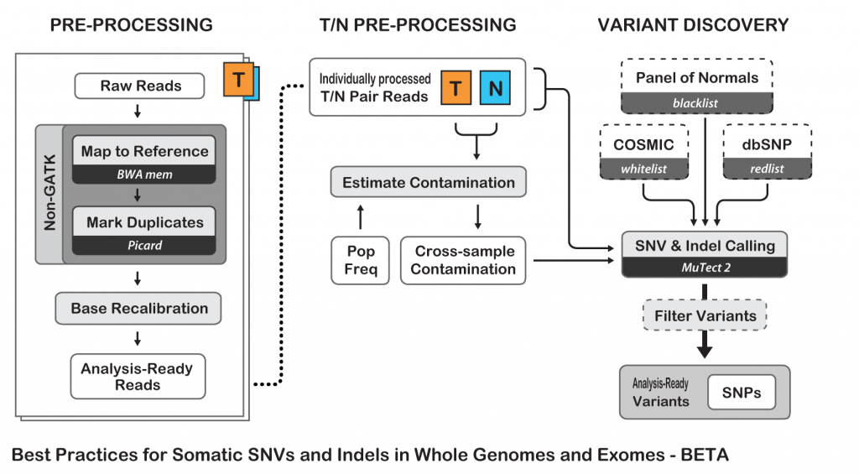

Figure . The recommended pipeline for calling somatic mutations using tumor/normal sequencing data (from https://software.broadinstitute.org).

* Variant calling

The most common in silico variant calling application for DNA sequencing in the context of cancer is the identification of somatic mutations. It is therefore essential to identify somatic mutations that presented in tumor cells but not normal cells as they may be drivers of the disease and/or targetable by a drug. Many software are available for the detection of somatic mutations, including Mutect (Cibulskis, et al. 2013), GATK (, https://software.broadinstitute.org/gatk/) and VarScan2 (Koboldt, et al. 2012). After the sequences of both normal and tumor DNA have been aligned to the reference genome, we can detect the positions where the sequenced DNA does not match the reference genome. The variant can either be somatic or germline based on whether or not the tumor sample matches the normal sample. Once a variant is called, a functional annotation is required in order to analyze the probable outcome of the variant. There are databases of known variants such as dbSNP (https://www.ncbi.nlm.nih.gov/SNP/) or polymorphisms and COSMIC (http://cancer.sanger.ac.uk/cosmic) for cancerous somatic mutations. If the variant was not previously documented, it is possible to make a prediction of its functional impact based on the effect of the mutation on the protein sequence. For non-silent mutations, software such as poly-phen (http://genetics.bwh.harvard.edu/pph2/), SIFT(Sim, et al. 2012), or MutationAssessor(Reva, Antipin, and Sander 2011) can be applied to predict the impact of the mutation on the structure and function of the protein product.

##### CGH array data

As the CGH array methods evaluate the different DNA quantities between the tumor sample and the normal sample (), the intensity data representing each probe is first transformed into a log2 relative ratio (LRR) of the intensity signals of the tumor and the normal samples.

* Centralization

To identify copy number variant, the first and critical step is to identify a baseline population of regions that have a copy number of 2. Under the hypothesis that regions that contain copy number changes are relatively small as compared to the whole genome (except for the cases of extreme unstable genomes where the whole or large part of chromosomes are amplified or lost), the centralization is equivalent to identifying the largest population of regions that have comparable LRR and then set its LRR as the base line of centralization. Method such as EM Expectation Maximization (EM) are effective for this purpose (Commo et al., 2015).

* Segmentation

Segmentation is a method for detecting breakpoints of copy number changes in the genome, which serves as an important step of the CGH array analyses workflow. Segmentation can also reduce the data noise by unifying the copy number of a segment where no abrupt copy changes are detected. Several segmentation methods can be applied such as the Hidden Markov Model (HMM; (Marioni, Thorne, and Tavaré 2006)), the GLAD algorithm (the gain and lost analysis of DNA; (Hupé, et al. 2004)), the CBS algorithm (circular binary segmentation; (Olshen, et al. 2004)) or the HaarSeg algorithm (Ben-Yaacov and Eldar 2008).

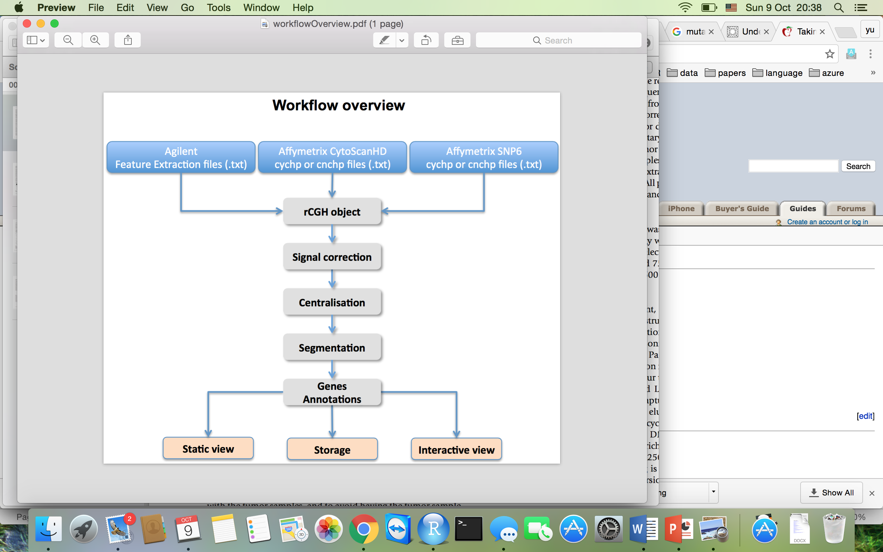

Figure . A workflow overview of CGH data analyses (from Commo et al., 2016).

* Copy number variant calling and interpretation

After centralization and segmentation, a threshold has to be set in order to call amplifications or deletions. This threshold is critical because it can generate false positive or false negative calls if improperly chosen, which can have a serious impact on treatment decision in precision medicine trials. For example, only patients with amplification of EGFR can benefit from an anti-EGFR inhibitor (Shen et al., 2014) and a wrong identification of an EGFR amplification may lead to poor drug response. There are many tools to call copy number variants from CGH data as well as visualization for easy interpretation such as CGHnormaliter (Van Houte et al., 2009) or rCGH (Commo et al., 2016).

#### Modeling genomic alterations in cancer

Somatic mutations in genes can affect the biological functions of their protein products and result in different behaviors in tumors cells from the normal cells. Mathematical modeling is a great tool when the data scale becomes too large to be handled manually. As the high throughput technologies allows the characterization of tumors in large scale, the need of the development and application of mathematical and computational models is greater than ever. The use of mathematical modeling has expended into many different areas of cancer research and has proven of great utility. A few examples are given here.

##### Cancer phenotype prediction

Accurate prediction of different tumor types has great value in providing better treatment options for cancer patients. The traditional method of cancer classification is based on morphological analysis of the cancer tissue and clinical information of the patients. For some highly heterogeneous cancer such as colorectal cancer (Vermeulen and Snippert 2014), such a classification is difficult to make, which will directly affect the therapeutic strategies and patients’ prognostic.

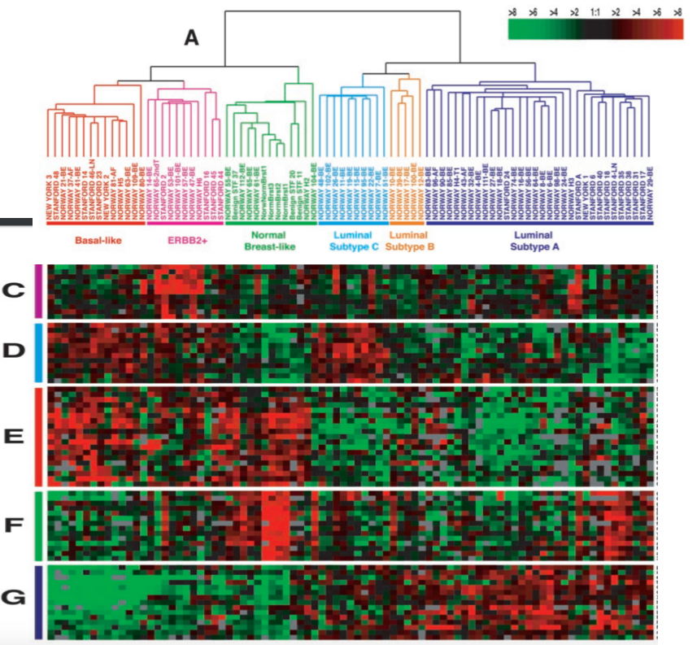

Figure . A set of 85 breast cancer samples were divided into five main subtypes by hierarchical clustering based on differences in gene expression. (Sørlie, et al. 2001)

Many studies have shown the utility of classifying tumors using gene expression data and machine learning algorithms such as clustering methods (Sotiriou, et al. 2003; Sørlie, et al. 2001) and tree methods (Dettling and Bühlmann 2003), and also shown their important implication in the medical diagnosis and prognosis. In particular, Sørlie, et al has shown that breast cancer samples can be robustly classified into five or six subtypes with different clinical outcomes based on gene expression data, which is a method that is still wildly used in classifying breast cancer patients (Figure 10).

##### Driver mutations identification

Driver mutations are mutations that provide an advantage to tumor cell formation and survival. Differ from driver mutation, passenger mutations are the mutations presented in tumors but not necessary for neither the transformation nor the survival of the tumor. In order to identify subgroups of patients who are most likely to benefit from a targeted therapy, which a drug designed to inhibit specific molecules, it is critical to distinguish driver mutation from passenger mutations. While an activated mutation in an oncogene or an inactivated mutation in a tumor suppressor gene is probably a driver mutation, the identification of the entire repertoire of driver mutations is not straightforward. First, it is not always easy to predict whether an unknown mutation is an activating or an inactivating mutation based only on the sequence changes. Second, a mutation can be a driver mutation even if it is not inside of a known oncogene, it can either have an impact on some other mechanism involved in cancer or can affect a new oncogene or tumor suppressor gene. Recently, researchers have proposed new methods () to identify driver mutations in a more systematic way using high throughput genomic data such as statistical test for identifying recurrent mutated genes or pathways from an ensemble of somatic mutations (Dees, et al. 2012) or genes with recurrent copy number and structural aberrations (Raphael, et al. 2014). Driver mutations can be used as biomarkers to enable treatment decision and prognosis in cancer.

|  |
| --- |
| Figure . A few popular software for identifying driver mutations from passenger mutations (Marx 2014). |

##### Mutational signature

The detection of mutational signature is a relatively new area that emerged thanks to the accumulation of sequencing data on cohorts of tumors. It is based on a mathematical model for the detection of patterns of somatic mutations in cancer cells that reflect the mutational processes at play in the cancer cells such as for example due to UV exposure. It has been shown that cells acquire preferentially C>T and CC>TT mutations under UV irradiation (HOWARD and TESSMAN 1964). A mutational signature is represented by the distribution of 96 types of mutation (each mutation can take 6 forms: C>A, C>G, C>T, T>A, T>C, T>G, leading to 96 types of mutation when taking into consideration the nucleotide just before (4 possibilities) and the one just after (4 possibilities) the mutated position) (). Studies have shown that by modeling the mutational pattern of a large number of tumors and their clinical information using matrix decomposition method, strong correlations can be observed between some mutational signatures and known mutagens (Alexandrov, et al. 2013). *Alexandrov et al.* identified and validated 21 mutational signatures in human cancer. Most of these signatures have distinct mutational distribution, for example the signature 3 has an even representation of all 96 mutations while the signature 1 is mainly represented by C>T mutations ().

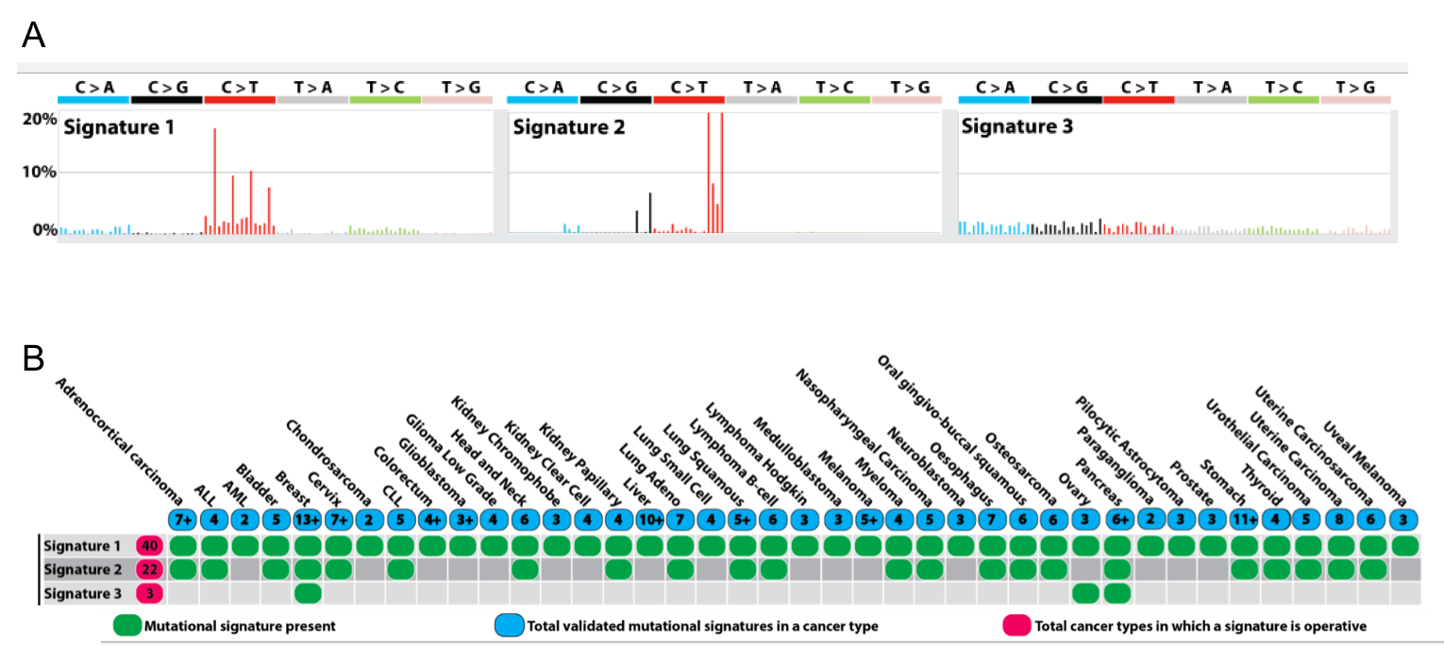

Figure . Three mutational signatures illustrated by the contribution of different mutation types (A), the presence of each signature in different cancer types (B) (Alexandrov, et al. 2013).

Mutational signatures can obviously reveal the biological processes of the origin of mutation in human but it still remains a research area of the utility of mutational signature in clinical use.

##### Gene network/interaction discovery

There are about 20,000 genes in a human cell, all these genes work in interaction with other genes to form a network, also called pathways, in order to carry out cellular processes of different functions. It is therefore important to identify various pathways to obtain a coherent global picture of cellular activity. Given the huge number of genes and the complex interactions undergoing in the cells, it is impossible to study pathways at a whole genome scale manually.

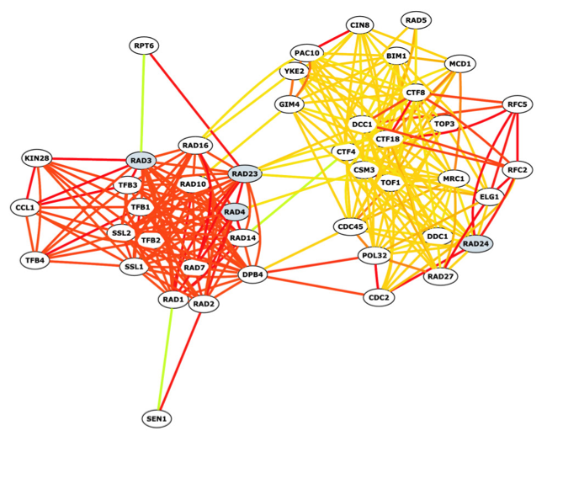

Figure . An example of gene network constructed by bioPIXIE using genome-wide data such as microarray expression data and gene-gene co-localization data (Myers, Chiriac, and Troyanskaya 2009).

Computational tools and mathematical models such as Naive Bayes model combined with gene expression data (Segal, Wang, and Koller 2003) or other types of genomic data (Myers, Chiriac, and Troyanskaya 2009) can be used to discover gene-gene interactions and build functional pathways. In particular, *Myers, Chiriac, and Troyanskaya* have shown that, using their method combine with genome-wide data, they could recover known functional gene networks as well as novel network components that were validated afterward by experiments (). This method can help us to better understand cellular biology by identifying unknown components of pathways as well as the relationship between different pathways that involve in different biological changes such as diseases.

## Personalized medicine

In all types of cancer, patients with different biological characteristics have different clinical behavior and response to treatment. With the help of large-scale high-throughput detection techniques, we now can collect large amount of molecular data from tumor specimens in genome, transcriptome and proteome level and treat patients based on the molecular characteristics of their tumor with targeted therapies, which is the concept of personalized medicine.

### Targeted therapy

Different from chemotherapy that aim at killing cancer cells in the process of replicating their DNA or dividing into new cells, targeted therapy works by modifying the processes that control cell growth, cell division, cell migration and cell signaling. Targeted therapies are small molecules or monoclonal antibodies that can inhibit the activity of the target or prevent it from binding to another protein that it normally activates. Small molecules compounds are typically developed for targets that are located inside the cell because such agents are able to enter cells relatively easily. Monoclonal antibodies, that are relatively large and generally cannot enter cells, are used for targets that are located outside or on the surface of the cell (such as receptors).

There are many targeted therapies under development, in clinical trials or have been approved by the drug control authorities to treat specific types of cancer. The development of a targeted therapy requires the identification of a good target that is, a target that play a key role in cancer cell growth and survival.

### Tumor profiling

Molecular tumor profiling is a critical step in the context of personalized medicine for identifying and characterizing the unique somatic genomic alterations in patients’ tumor so that suitable targeted therapies could be given to the patients.

Based on the targeted therapies available for the corresponding cancer type, different approaches might be appropriate for the profiling. For instance, to test a patient with non-small cell lung cancer for an EGFR inhibitor, a targeted sequencing of the tumor can be suitable to identify a specific activating mutation in EGFR such as exon 19 deletion or L858R mutation in exon 21, in which case the inhibitor Erlotinib has shown better outcomes than traditional chemotherapy (Rosell, et al. 2012). In breast cancer patients, where 3 hormone receptors (the estrogen receptor (ER), progesterone receptor (PR) and erb-b2 receptor tyrosine kinase 2 (ERBB2 or HER2)) are routinely tested for a diagnosis of the cancer type as well as a possible treatment, an IHC staining or FISH assay (for HER2) is often used to test the receptors’ expression level in tumor cells. The tumor can then be classified into different subtypes based on the status of these 3 receptors and will help defining the optimal treatment.

In another type of clinical trial where multiple targeted therapies are available, patients can receive a broader test for biomarkers. For example, a subgroup of patients in clinical trial MOSCATO-01 at Gustave Roussy (Charles Ferté 2014) have received a high throughput genomic analysis (CGH and DNA targeted sequencing of a panel of 74 target genes) to detect biomarkers that finally oriented the patients towards different type of targeted therapies.

In retrospective research studies, the tumor profiling can be done at much larger scale such as whole genome sequencing, whole exome sequencing and RNA-seq to identify new biomarkers.

### Matching patients to targeted therapy

The current way of defining the targeted therapy for a cancer patient is rather straightforward: patients are usually given one targeted therapy corresponding to a genomic alteration in a known targetable gene identified in its tumor. In the standard care of certain advanced or metastatic cancer patients, if the patient is a potential benefiter for one targeted therapy, then only the corresponding target is tested and the patient will receive the targeted therapy alone or combined with chemotherapy only if the target is positive, otherwise an alternative treatment is given if available such as immunotherapy. For example, metastatic melanoma patients with a V600E mutation in BRAF are treated with anti BRAF targeted therapy, while patients without this mutation can also benefit from immune therapy (Robert, et al. 2015).

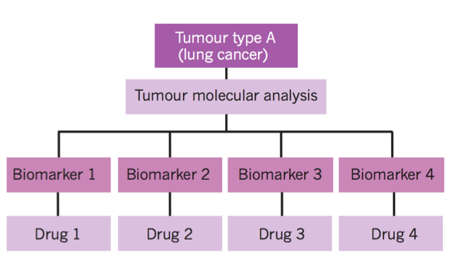

Figure . An example of a clinical trial design of one type of cancer in which multiple drugs are available. Patients are tested for biomarker1, biomarker2, biomarker3 and biomarker4, and receive a corresponding drug based on their molecular analysis result (Biankin, Piantadosi, and Hollingsworth 2015).

In personalized medicine programs, multiple targets are tested and patients are redirected towards clinical trials with corresponding targeted therapy (). For example, in the clinical trial MOSCATO at Gustave Roussy, multiple targeted therapies are available for patients. The enrolled patients are first tested for mutations in a panel of more than 70 genes and copy number variations of genes to identify biomarkers. Patients are then treated by targeted therapies if they are positive for the corresponding biomarker. Such type of clinical trial offers cancer patients a much bigger opportunity to receive a suitable treatment, but there are still some limitations.

### Limitations

#### Lack of biomarkers/drugs

Despite the promise of personalized cancer treatments, not all types of cancer have personalized treatment options because of lack of promising biomarkers or available approved targeted therapies in the corresponding cancer type (). Genetic testing for patients and tumor samples can be costly and time-consuming and sometimes disappointing when only a small proportion of patients enrolled are positive for treatable biomarkers (André, et al. 2014).

|  |
| --- |
| Table . A table of frequently mutated genes in lung cancer and available or in development targeted therapies. Approved targeted therapies are only available for EGFR and ALK alterations; targeted therapies for HER2 and DDR2 showed negative results; targeted therapies for KRAS, BRAF are still under clinical trials; and no targeted therapy’s available for targets as PTEN, NRAS(Lovly 2016; Chan and Hughes 2015). |
|  |

In some cases, even if an oncogenic alteration is identified, drugs for the target are difficult to develop because of the target’s structure and/or the way its function is regulated in the cell. One example is RAS, a signaling protein that is mutated in as many as one-quarter of all cancers but it has not been possible to develop inhibitors of RAS signaling with existing drug development technologies (https://www.cancer.gov/about-cancer/treatment/types/targeted-therapies/targeted-therapies-fact-sheet). Moreover, a large number of cancer drugs have not been linked to specific genomic alterations that could be used as biomarkers to specify their selective therapeutic effectiveness (McDermott and Settleman 2009). Systematic study is needed to discover the deeper relationships between biomarkers and drug response in order to optimize the utility of existing drugs as well as the development of new drugs and the identification of new biomarkers.

#### Drug resistance

A subgroup of patients can benefit from therapies targeting cancer driver mutations identified from the characterization of their tumor. For example, from 10% to 30% of patients with non-small cell lung cancer have mutations in EGFR, of which 75% have been shown to respond to the tyrosine kinase inhibitors (TKIs) Gefitinib (Maemondo, et al. 2010). However, almost all of the patients that initially benefit from the EGFR inhibitors eventually develop resistance and relapse, the median progression free survival (PFS) after treatment with Gefitinib in patients has been shown as less than a year. Some mechanisms of resistance have already been identified such as the co-existence of the abnormal activation of HER2, BRAF, MAPK1 or PIK3CA but many of the remaining mechanisms are still unknown *(Stewart, et al. 2015,* Figure 15*)*.

Drug resistance to targeted therapy is generally classified into two types: 1) early intrinsic resistance referring to a lack of treatment response and 2) late acquired resistance referring to disease progression after initial response. The intrinsic resistance may be caused by the differential drug sensitivities across various genomic alterations in the target, for example, cells with different EGFR alterations do not respond equally to the TKI inhibitors, the exon 19 deletion and L858R mutation are associated with high sensitivity to TKIs while exon 20 insertion, which are typically located after the C-helix of the tyrosine kinase domain of EGFR, seem to be resistant to EGFR inhibitors (Yasuda, Kobayashi, and Costa 2012), which demonstrated the importance of identifying the driver mutations not only by gene but also by mutation. Another scenario of an intrinsic resistance can be explained by the co-existence with the sensitizing genomic alteration of a secondary genetic alteration.

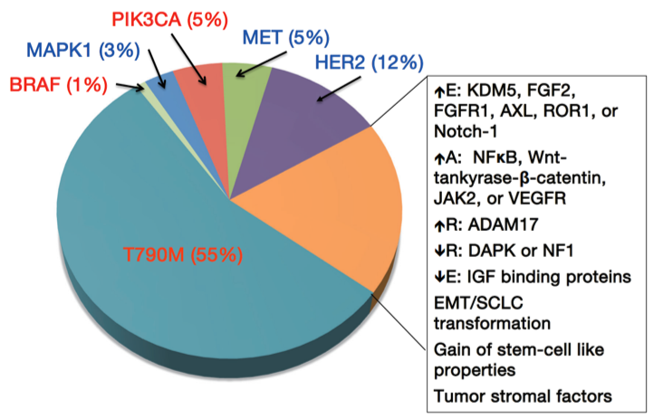

Figure . Summary of mechanisms of resistance to first generation EGFR TKIs. Red text represents mutations; blue text represents amplifications. ↑E increased expression; ↑A, increased activation; ↑R, up-regulation; ↓R, down-regulation; ↓E, loss of expression (Stewart, et al. 2015).

The late acquired resistance may be the result of a secondary mutation in the primary oncogene so that targeted therapy no longer interacts well with it. For example, lung cancer patient with EGFR mutation develop resistance to anti EGFR TKI by acquiring a secondary mutation T854A in EGFR (Bean, et al. 2008). The acquired resistance can also be due to the selection of clones harboring resistant mutations initially present in the tumor at low percentage and expanding during treatment. These events might be predicted based on the genomic profile of the patients through bioinformatics tools. For example, the EGFR T790M mutation has been associated with intrinsic resistance to EGFR TKI therapy in patients with activating EGFR mutations. Even at a very low frequency of the T790M mutation in the tumor, the pressure from targeted agents may select the T790M clones and lead to an overall resistance (Stewart, et al. 2015).

#### Overcome limitations

In order to overcome these two main limitations of personalized medicine, many efforts have been done in the following directions:

* New drugs and new targets

Great efforts in developing more specific and more efficient inhibitors have been made leading to the development and use of second-generation inhibitors. For instance, the first generation of mTOR inhibitors, such as rapamycin, is being replaced by its second generation, such as AZD8055. Meanwhile, countless efforts are being made to develop third generation mTOR inhibitor that could overcome drug resistance (Rodrik-Outmezguine, et al. 2016). At the same time, attempts to identify new mechanisms of response to existing drugs as well as new potential targets are being made constantly from large scale genomic profiling analyses to their in vitro and in vivo validations (Nicolas Goossens 2015).

* Combine multiple inhibitors

One common practice to overcome drug resistance is to combine a targeted therapy with one or more chemotherapy drugs. For example, the targeted therapy trastuzumab has been used in combination with docetaxel, a traditional chemotherapy drug, to treat women with metastatic breast cancer that overexpress the protein HER2/neu (Burris 2001). The other option is to give the patients combinations of targeted therapies based on their genomic profiles. Many recent studies have demonstrated the benefits of combining targeted therapies in overcoming resistance that arises through secondary mutations in the driver genes. The combination can either be 2 or more drugs targeting the same altered signaling pathway or targeting different pathways based on the patients’ genomic profiles. For example, treating melanoma patients with a BRAF V600E mutation with the combination BRAF inhibitor (Vemurafenib) / MEK inhibitor (Cobimetinib) as compared to the single BRAF inhibitor, can slow the development of resistance and therefore the disease progression (Larkin, et al. 2014, Figure 16). Some preclinical studies and early-phase clinical trials have also shown potential antitumor activities of the combination of MEK inhibitor and PI3K inhibitor with manageable safety and toxicity for patients with RAF or RAS mutations (Jokinen and Koivunen 2015).

|  |
| --- |
| Figure . Dual therapy of BRAF inhibitor and MEK inhibitor increased progression-free survival when compared to BRAF inhibitor monotherapy. (Larkin, et al. 2014) |

In order to find the right combination of drugs, it is essential to first identify the most prevalent targets as well as their interaction in tumor cells in the response to the drugs. But the contribution of the combinations of genomic alterations to the cancer phenotype and response to treatment is still poorly understood. Plus, most candidate gene association studies typically assess the effects of candidate genes independently of each other making the identification of gene-gene interactions in the discovery of biomarkers to drug response difficult.

Drug testing in cell lines is one of the initial steps in drug development and allows the access to a large number of Drug testing in cell lines is one of the initial steps in drug development, it allows the access to a large number of potential drugs, at different concentrations. It permits to analyze the drugs mode of action, test the combination of drugs as well as offer the possibility of studying the association of signaling pathways to therapeutic response. The characterization of cancer cell lines with high throughput sequencing technologies is a powerful tool to provide insight into the pharmacogenomics of tumor cells.

## Modeling pharmacogenomics data of cell lines

### Rationale for studying cancer through cell lines

Human cancer cell lines are biological models that represent a wide range of tumor biology with great diversity. A cancer cell line is a collection of immortalized cancer cells of one tumor. Although there is a debate about whether the cell lines are representative of the original tumor, a high, but not perfect, similarity between the original tumor and the cancer cell lines derived from it can be observed at the level of genomic alterations and gene expression (Masters 2000). We can discover the biological mechanistic and connect the genomic alterations to drug sensitivity through experimental manipulation of cancer cell lines such as deep analysis at the genomic level or drug response at different concentrations so that further studies and eventually rationale clinical trials could be designed to test these hypotheses. Cancer cell lines are widely used in research for studying the biology of cancer and testing cancer treatments for the following reasons: 1) Cell lines provide an almost unlimited supply of cells with similar genotypes and phenotypes; 2) Cell lines are easy to manipulate (cell lines can be genetically or epigenetically altered using demethylation agents, siRNA, expression vectors and drugs) and easily molecularly characterized; 3) experiments can be reproduced in the same condition.

Two pharmacogenomics projects, the “Genomics of Drug Sensitivity in Cancer” (GDSC), (Garnett, et al. 2012) and the “Cancer Cell Line Encyclopedia” (CCLE), (Barretina, et al. 2012), collectively characterized more than 1,000 cell lines tested with more than 150 anti-cancer drugs for their sensitivity, providing valuable comprehensive molecular characterization and drug response of the cancer cells of different origins. This molecular characterization gives the opportunity to study the relationship between genomic features and drug responses, and identify the genomic biomarkers of drug sensitivity.

* GDSC

“Genomics of drug sensitivity in cancer “characterized 1,074 cell lines of different types of cancers of different origins by whole exome sequencing (Agilent sureselectXT human all exon 50Mb bait set), gene expression (Affymetrix human genome U219 array), copy number alterations (Affymetrix SNP6.0 array), DNA methylation (Illumina human methylation 450 array), gene fusion (targeted PCR sequencing or split probe FISH analysis) and microsatellite instability. Most of these cell lines were also tested at different concentrations for 138 drugs, including chemotherapies and targeted therapies.

* CCLE

“The Cancer Cell Line Encyclopedia” (CCLE) enables predictive modeling of anticancer drug sensitivity, with a collection of gene expression (Affymetrix U133 plus 2.0 arrays), copy number (Affymetrix SNP 6.0 array), point mutations (targeted sequencing) of 947 human cancer cell lines with pharmacologic profiles for 24 anticancer drugs (8-dose drug sensitivity assay) across 479 of the cell lines.

### Predictive models to identify biomarkers

One of the most exciting opportunities presented by large scale genomic data of a large number of cancer cell lines is the possibility to build analytic models to study cancer biology. In both original database publications, a predictive model, elastic net regression was applied to identify biomarkers that related to the drug response. The use of this model in both studies allowed interesting discoveries about how genomic features related to the drug response. For example, in the study of GDSC, EWS-FLI1 gene translocation was identified as a sensitivity biomarker to PARP inhibitors in Ewing’s sarcoma cells and validated in mouse models.

#### Elastic net

Elastic net (Zou and Hastie 2005) is a regularized regression method that linearly combines the $l_{1}$  penalty (LASSO, least absolute shrinkage and selection operator) and $l_{2}$ penalty (ridge). By using a parameter alpha that takes value between 0 and 1, elastic net adjusts the weight of the LASSO and ridge penalization based on the data.

For a given response $y=\left(y_{1}, y_{2}, …, y_{n}\right)$ and predictors $X=\left(X_{1}, X_{2}, …, X_{p}\right)$ where $X_{j}=\left(x_{1}, x_{2}, …, x_{n}\right)', j=1, 2, …, p$, a regression problem is to estimate the parameters in:

|  |  |
| --- | --- |
|  | ( ) |

An elastic net model is to solve equation (1) by solving equation (2) which is a penalized form of equation (1);

|  |  |
| --- | --- |
|  | ( ) |

Where are non-negative and ${\left|β\right|}^{2}= \sum_{1}^{p}{{β_{j}}^{2}}$, $\left|β\right|= \sum_{1}^{p}{\left|β_{j}\right|}$.

Let $α=\frac{λ_{1}}{(λ_{1}+ λ_{2})}$, then solving equation (2) equals to optimize:

|  |  |
| --- | --- |
| , | (3) |

Elastic net has been shown to be suitable for the p>>n problem where the number of predictors are much larger than the number of observations, and for the case where the predictors are highly correlated (Zou and Hastie 2005). Given these two properties of elastic net, it is suitable for large-scale genomic data such as gene expression data where the number of predictors can be as large as more than 20,000 genes and some of the genes are strongly correlated.

#### Random forest

Random forest (RF, Breiman 2001) is a popular supervised machine learning algorithm made of an ensemble of decision trees (). Many studies have shown its capability in prediction and classification (Bienkowska, et al. 2009; Riddick, et al. 2011; Stetson, et al. 2014). As the decision tree is a pure machine learning method with no probabilistic assumption about the input or output variables, no particular pretreatment is needed before using the random forest model. Unlike most of the probabilistic machine learning models, there is no assumption about the relationship between the input variables therefore they can be independent, linearly correlated or non-linearly correlated. It is therefore adapted to the situation where no assumption can be made about the relationship between the input and the output variables, or the relationship between the input variables, which is the case in the genomic alteration-drug response scenario.

|  |
| --- |
| Figure . Framework of Random Forest. |

There are two main ideas in Random Forest (RF), one is to build trees with bootstrapped data set (also called bagging), and the other is to randomly select a subset of predictive variables to test for best split. These two characteristics of RF give it unique qualities in predictive modeling. Indeed, the use of bagging in the construction of the predictive model allows the predictive error to be estimated simultaneously, thus no additional cross validation is required. By performing random selection of data set to use and predictive variable to split, RF build a set of distinct trees so that overfitting can be avoided. Importantly, RF assesses a variable importance by calculating the difference of predictive accuracy after permuting the variable value, the bigger the decrease of predictive accuracy, the more important the variable is. This important feature is extremely suitable for identifying predictive biomarkers.

Although random forest does not have complex parameters to tune before running, there are still some to fix, such as the number of trees to grow (tradeoff between performance and cost), the number of observations to use to build a tree in the bagging procedure, the number of input variables to use at each split (the bigger the number, the bigger the impact of correlated input variables in the model). Apart from these parameters of RF, a few parameters (ex; matrix for evaluating the split) of the decision tree can vary based on the nature of the data set and the purpose of the model.

##### Classification and regression trees

Decision tree learning is a nonlinear data mining method that can predict the value of a target variable based on several input variables. There are two main types of tree learning models based on the nature of the target variable: classification tree with a categorical target variable and regression tree with a continuous target variable. Decision tree model is a [predictive model](https://en.wikipedia.org/wiki/Predictive_modelling) that matches each observation to series of decisions based on input variables. It is one of the predictive modeling approaches most used in statistics, data mining and machine learning. In these tree structures, the ensemble of the observations is called the root, leaves represent categorical labels or observations with a certain range of the split input variable and branches represent the input variables that lead to those splits. The node to split is called the parent node and the nodes after the split are called daughter nodes. A tree learning objet can be built by splitting the data into different subgroups (nodes) based on one input variable at each time. A tree is binary when the parent nodes are split into two daughter nodes at each time based on one variable (for example, a categorical variable with two categories or a continuous variable split at a cutoff value). Binary tree is the most frequently used tree model.

##### Split criteria

Based on the type of trees and implementations, there are different ways to evaluate a split so that the algorithm can decide which variable to split on and associate an importance to the variable used. The main goal is to split the node into more homogeneous nodes regarding the output variable. For a regression tree with a continuous output variable, the most frequent method to evaluate a split is to evaluate the variance in the node before the split and the one after. One common way is to calculate the difference of the sum of squared error (SSE) between the parent node and the sum of the two daughter nodes and choose the variable that leads to the biggest decrease in SSE. In the case of classification tree, entropy, information gain and GINI index are commonly used.

One other approach is to use corrected statistical tests (i.e. permutation-based significance tests) as splitting criteria by computing a p-value for each input variable in the selection of best variable to split. This approach can reduce bias due to the different nature of the input variable, for example, continuous variables tend to be selected more often than categorical variables and categorical variables with more categories tend to be selected more often than the ones with fewer categories. The computing cost is however much higher than non-statistical based splitting criteria, thus the statistical based split criteria is less used in practice.

# Results

## cmDetect -- ctDNA mutation calling method for whole exome sequencing of tumor/whole blood samples

### Somatic mutation identification using whole exome sequencing data

As discussed previously, identifying somatic mutations in patients’ tumor using whole exome sequencing is a useful way to characterize and study the genetics of tumors. In order to identify somatic mutations for cancer patients, both the tumor DNA and germline DNA have to be sequenced and compared. For solid tumors, the source of tumor DNA is often a biopsy of the tumor, while the source of germline DNA can be a biopsy of normal tissue or the peripheral blood. As the peripheral blood is relatively easy to collect, it is often the choice of the source of germline DNA.

### False negatives caused by cell-free circulating tumor DNA in whole blood

Normal or tumor cells release DNA in the blood stream when they are under apoptosis. As tumor cells normally have a more active cell reproduction and apoptosis, they can release an important amount of cell-free DNA regardless of the relative size of the tumor as compared to the whole human body, especially for the cancer patients who went through therapies (radiotherapy, chemotherapy, and other cancer treatments cause cell death by apoptosis). A higher than normal concentration of circulating DNA may already be detected even in early stage of cancer where there is little cell death (van der Vaart and Pretorius 2007). As the cancer burden increases, so does the rate of cell death and the amount of proliferating cancer cells, with a concomitant increase in release of fragments of DNA. This cell-free DNA that came from the tumor is called circulating tumor DNA (ctDNA) (Schwarzenbach, Hoon, and Pantel 2011).

|  |
| --- |
| Figure . ctDNA in peripheral blood prevent accurate identification of somatic mutations using whole exome sequencing data |

Numerous publications have shown ctDNA as a noninvasive biomarker of tumor in clinical medicine (Gordon 2016; Ai, et al. 2016; Cheng, Su, and Qian 2016; Schwarzenbach and Pantel 2015). As the same time, the presence of ctDNA can be seen as a source of contamination of the germline DNA, especially when the DNA extracted from the blood is used as a control. In that case, the detection of somatic mutation using whole blood as the source of germline DNA can cause false negatives, i.e. true somatic mutations filtered out as they are also detected in the germline DNA, with current somatic mutation detection software. Facing this problem, we developed a method called cmDetect to run as a complementary tool to traditional somatic callers in order to avoid false negatives ().

Publication

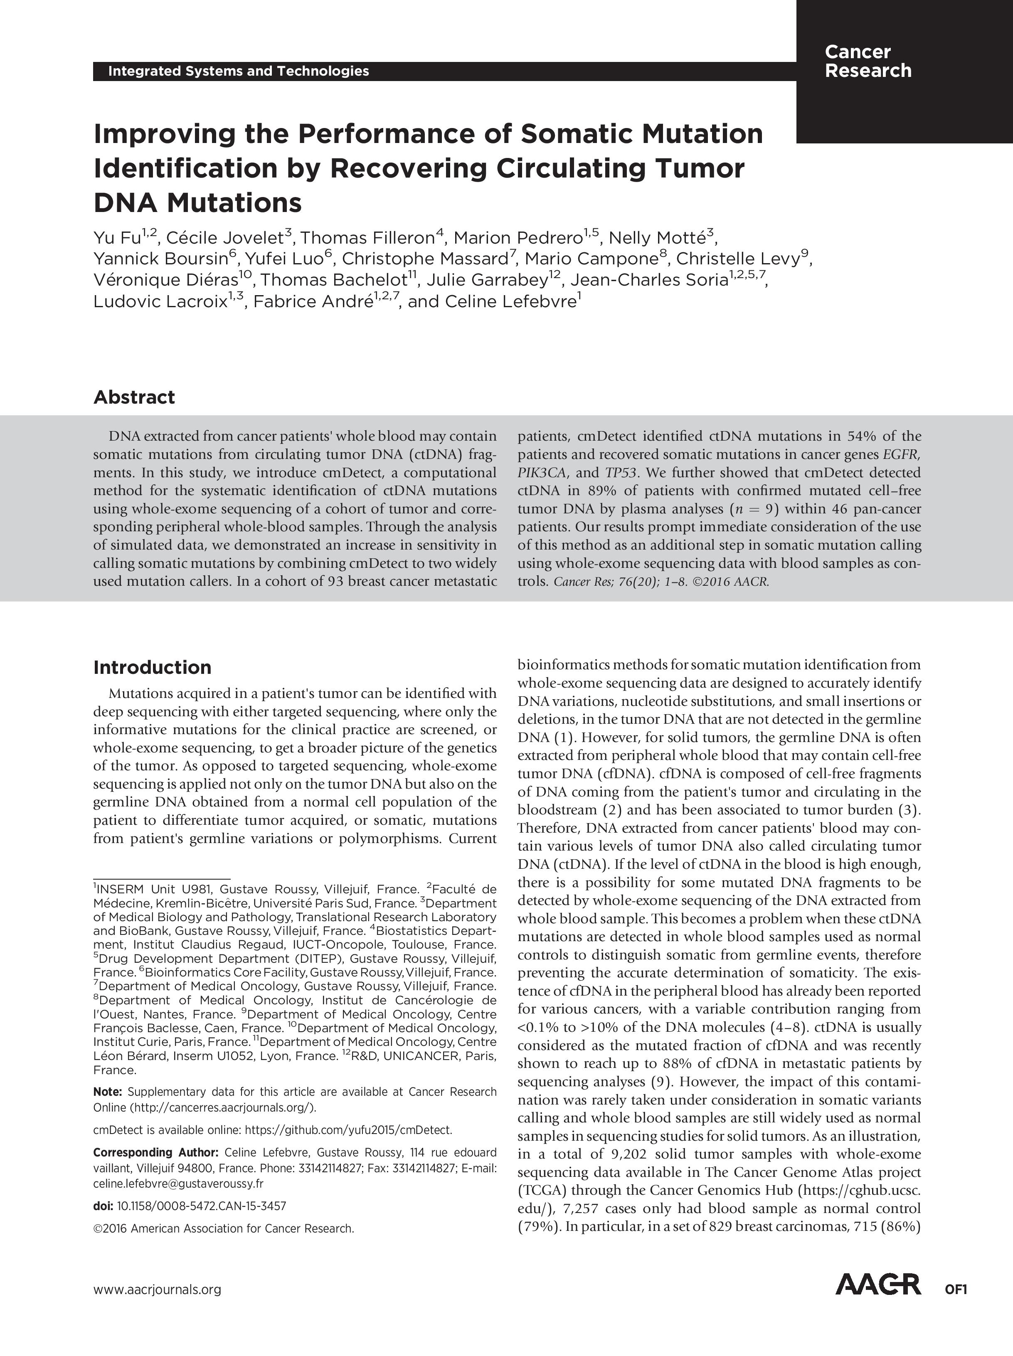

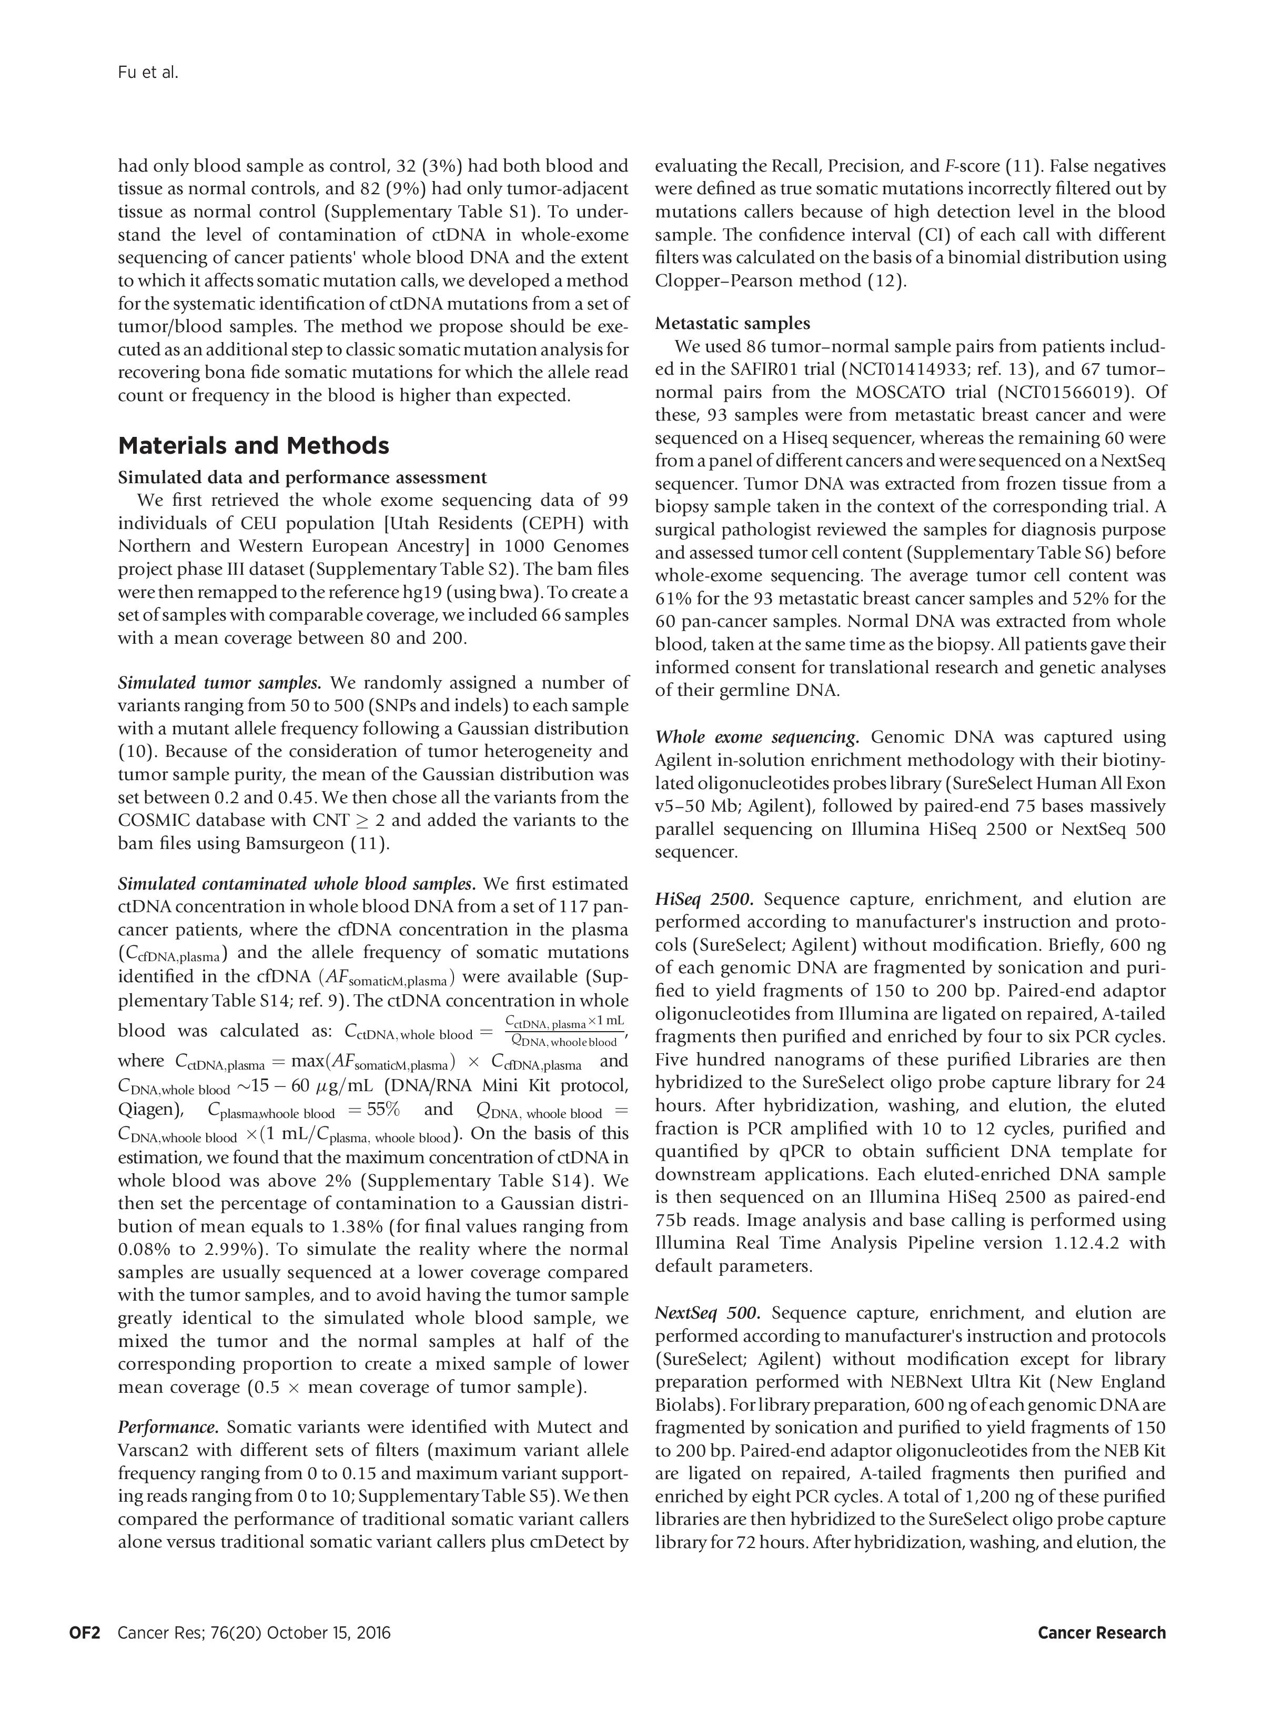

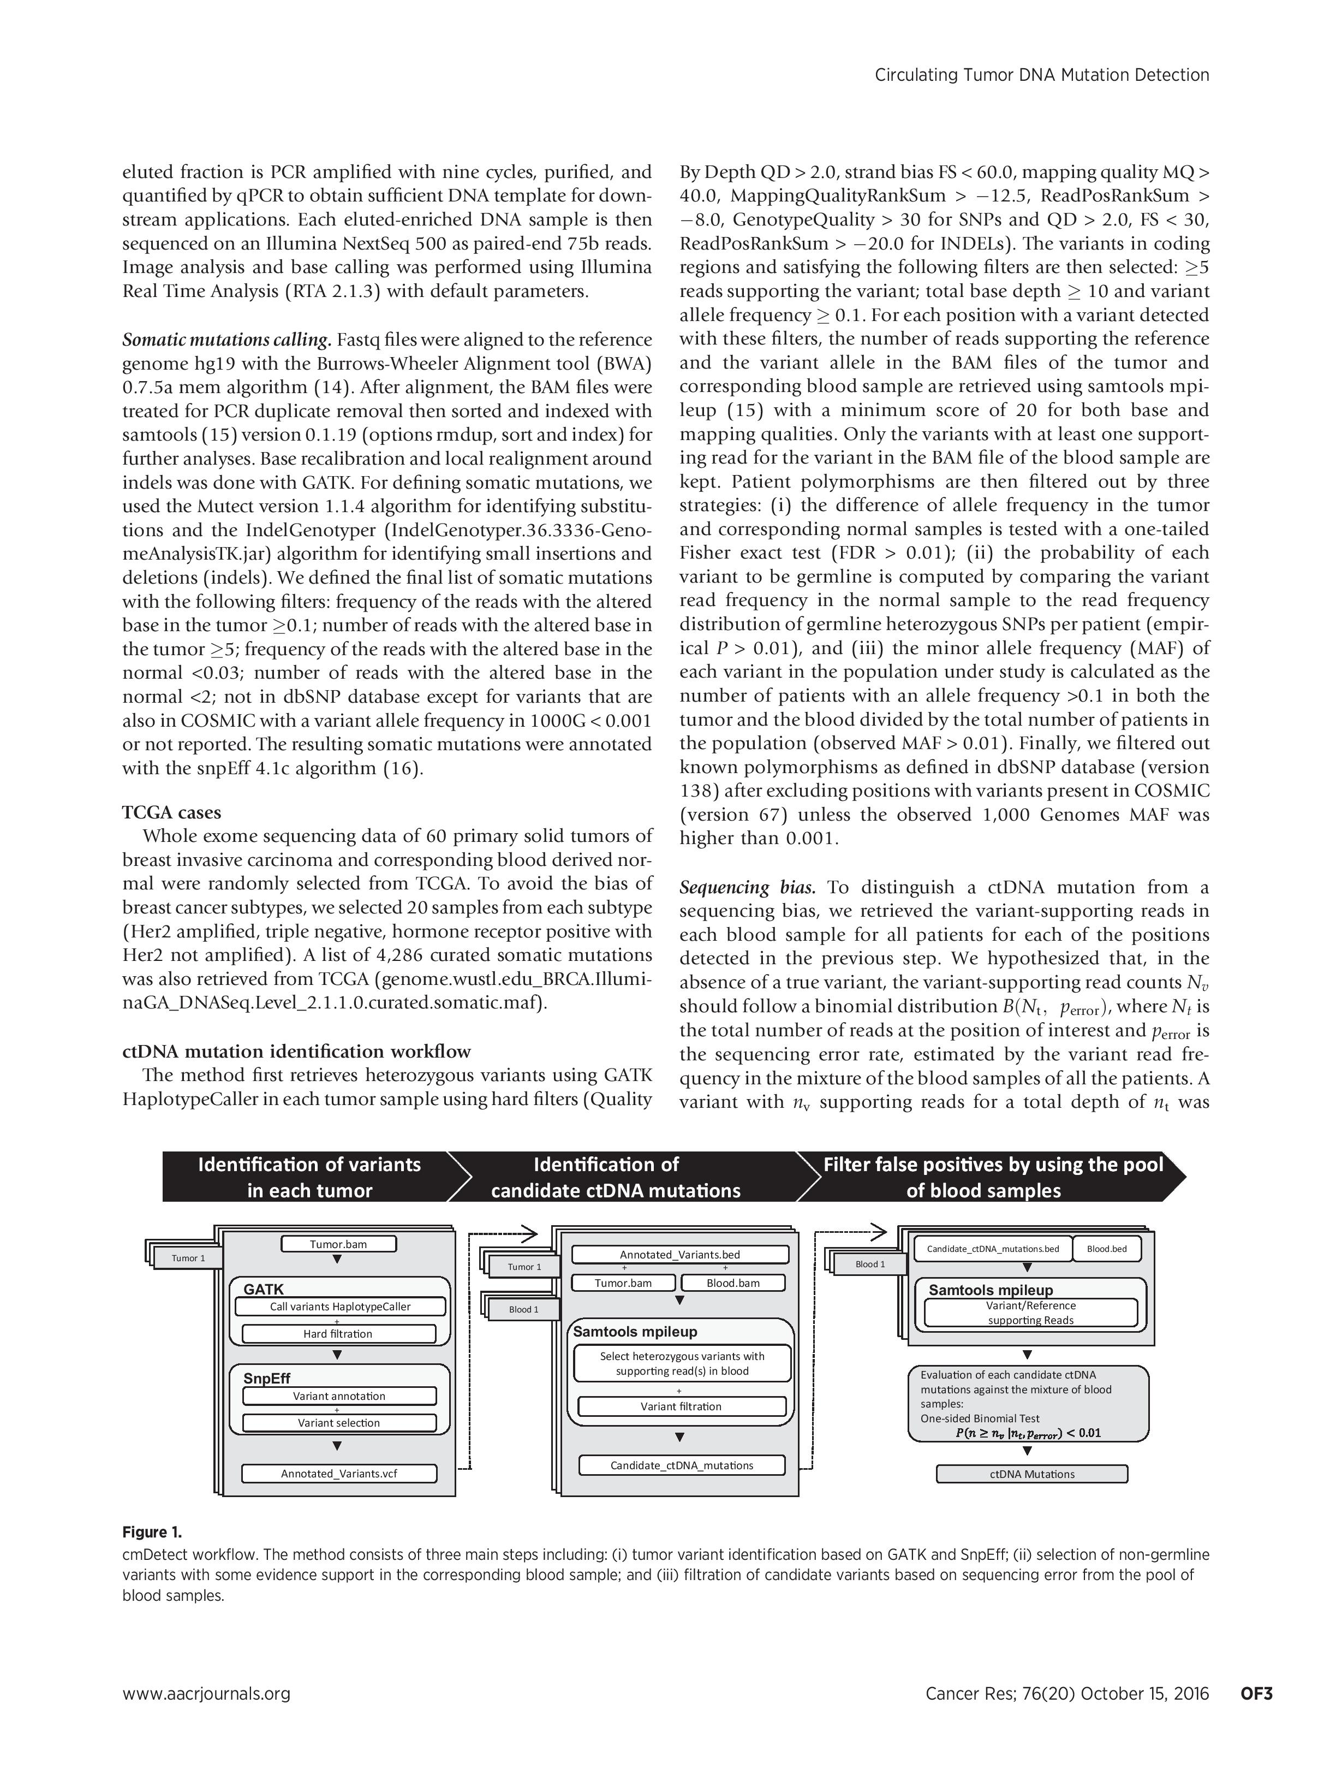

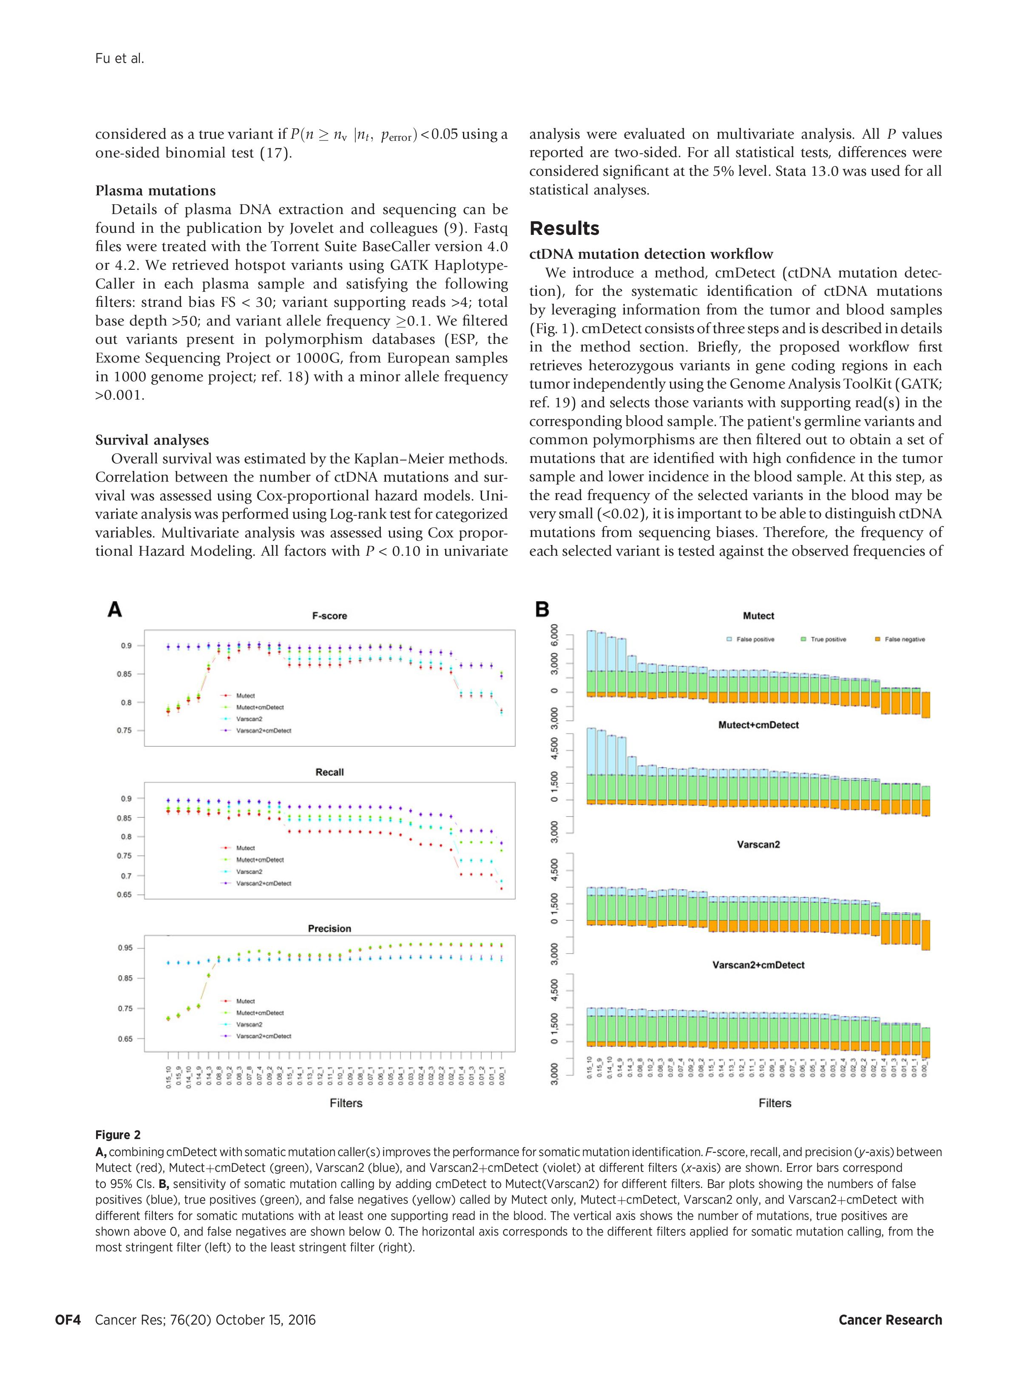

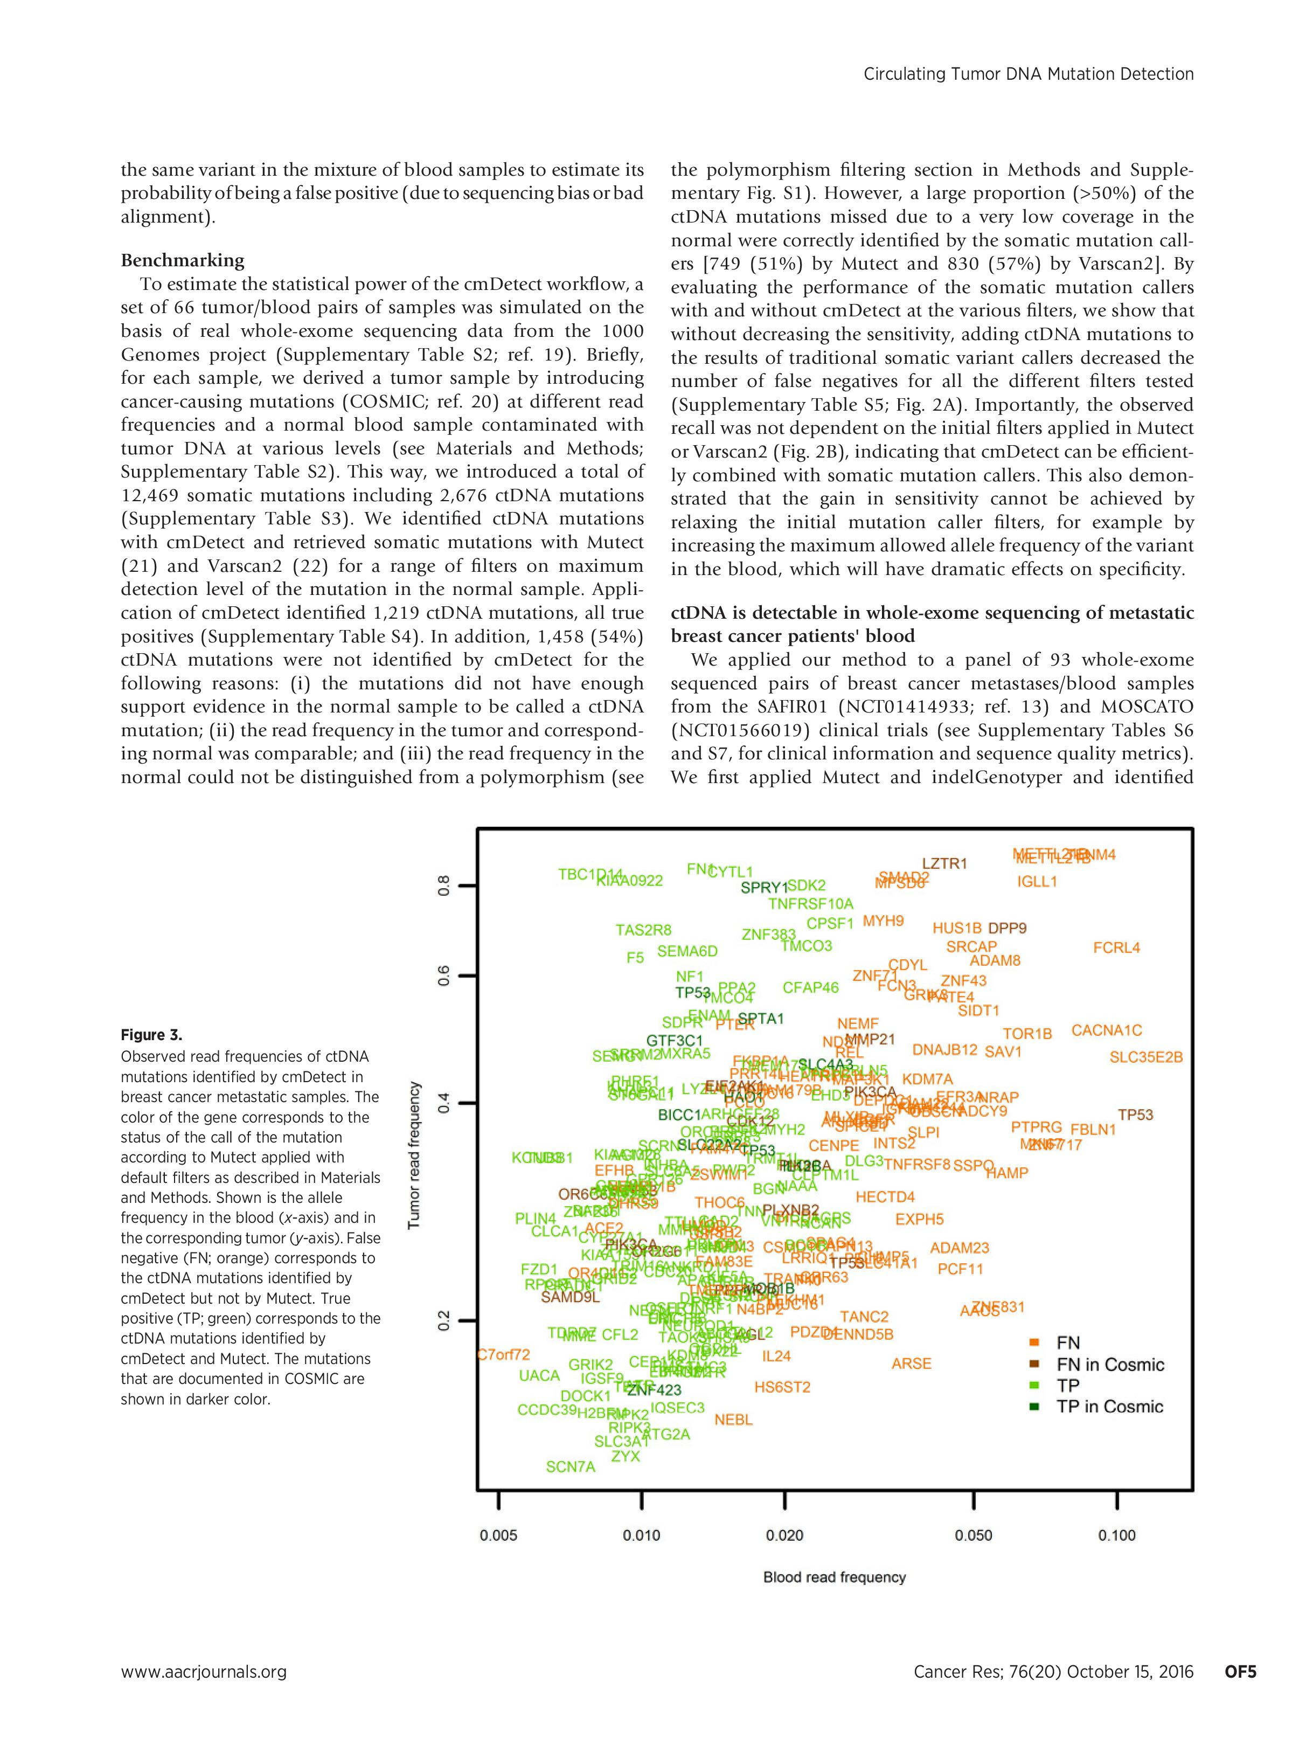

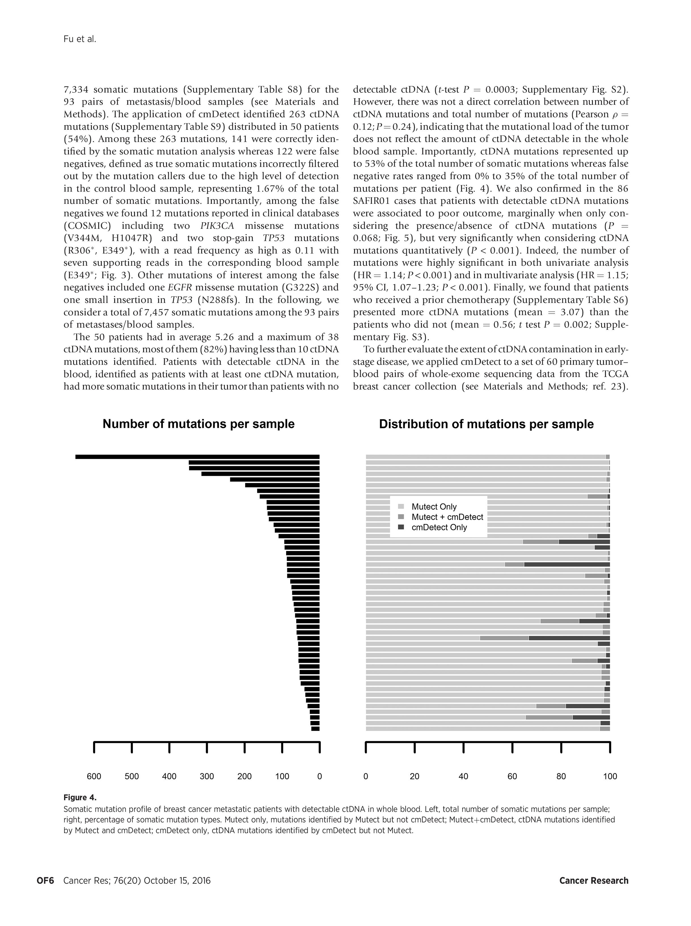

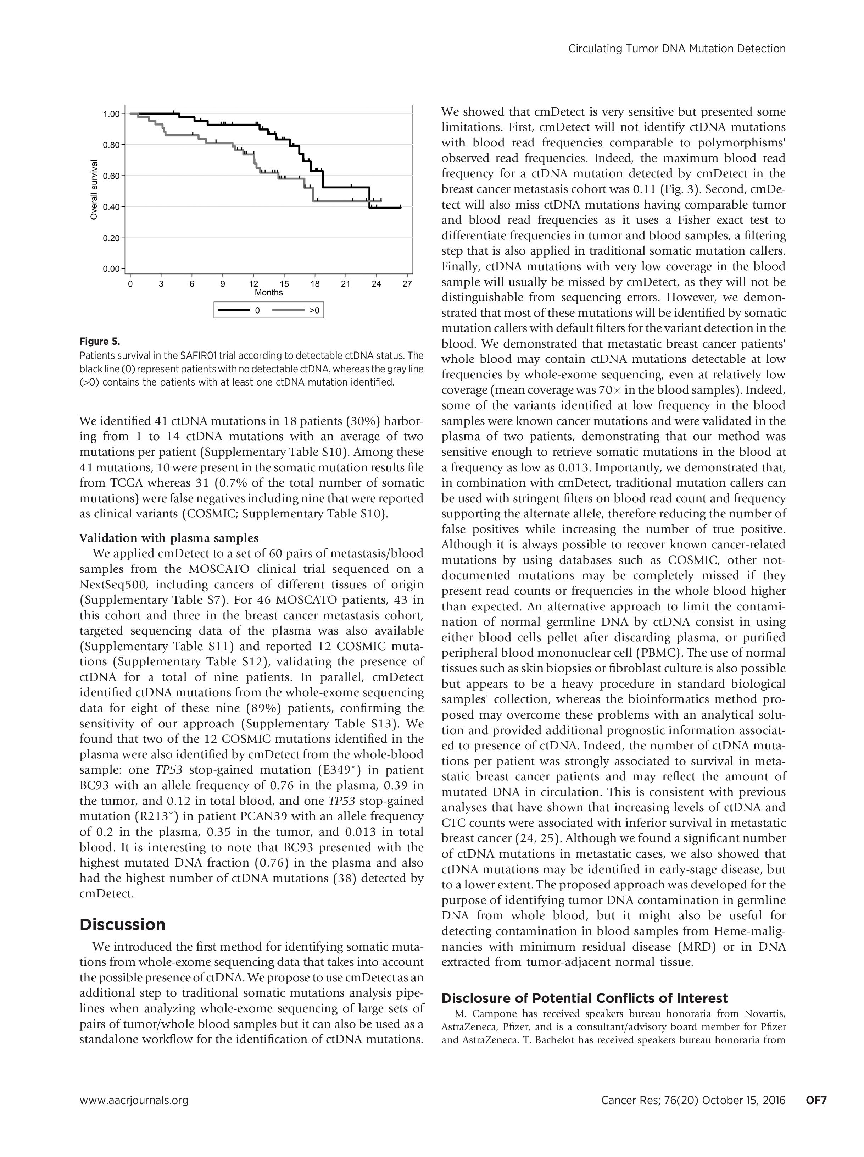

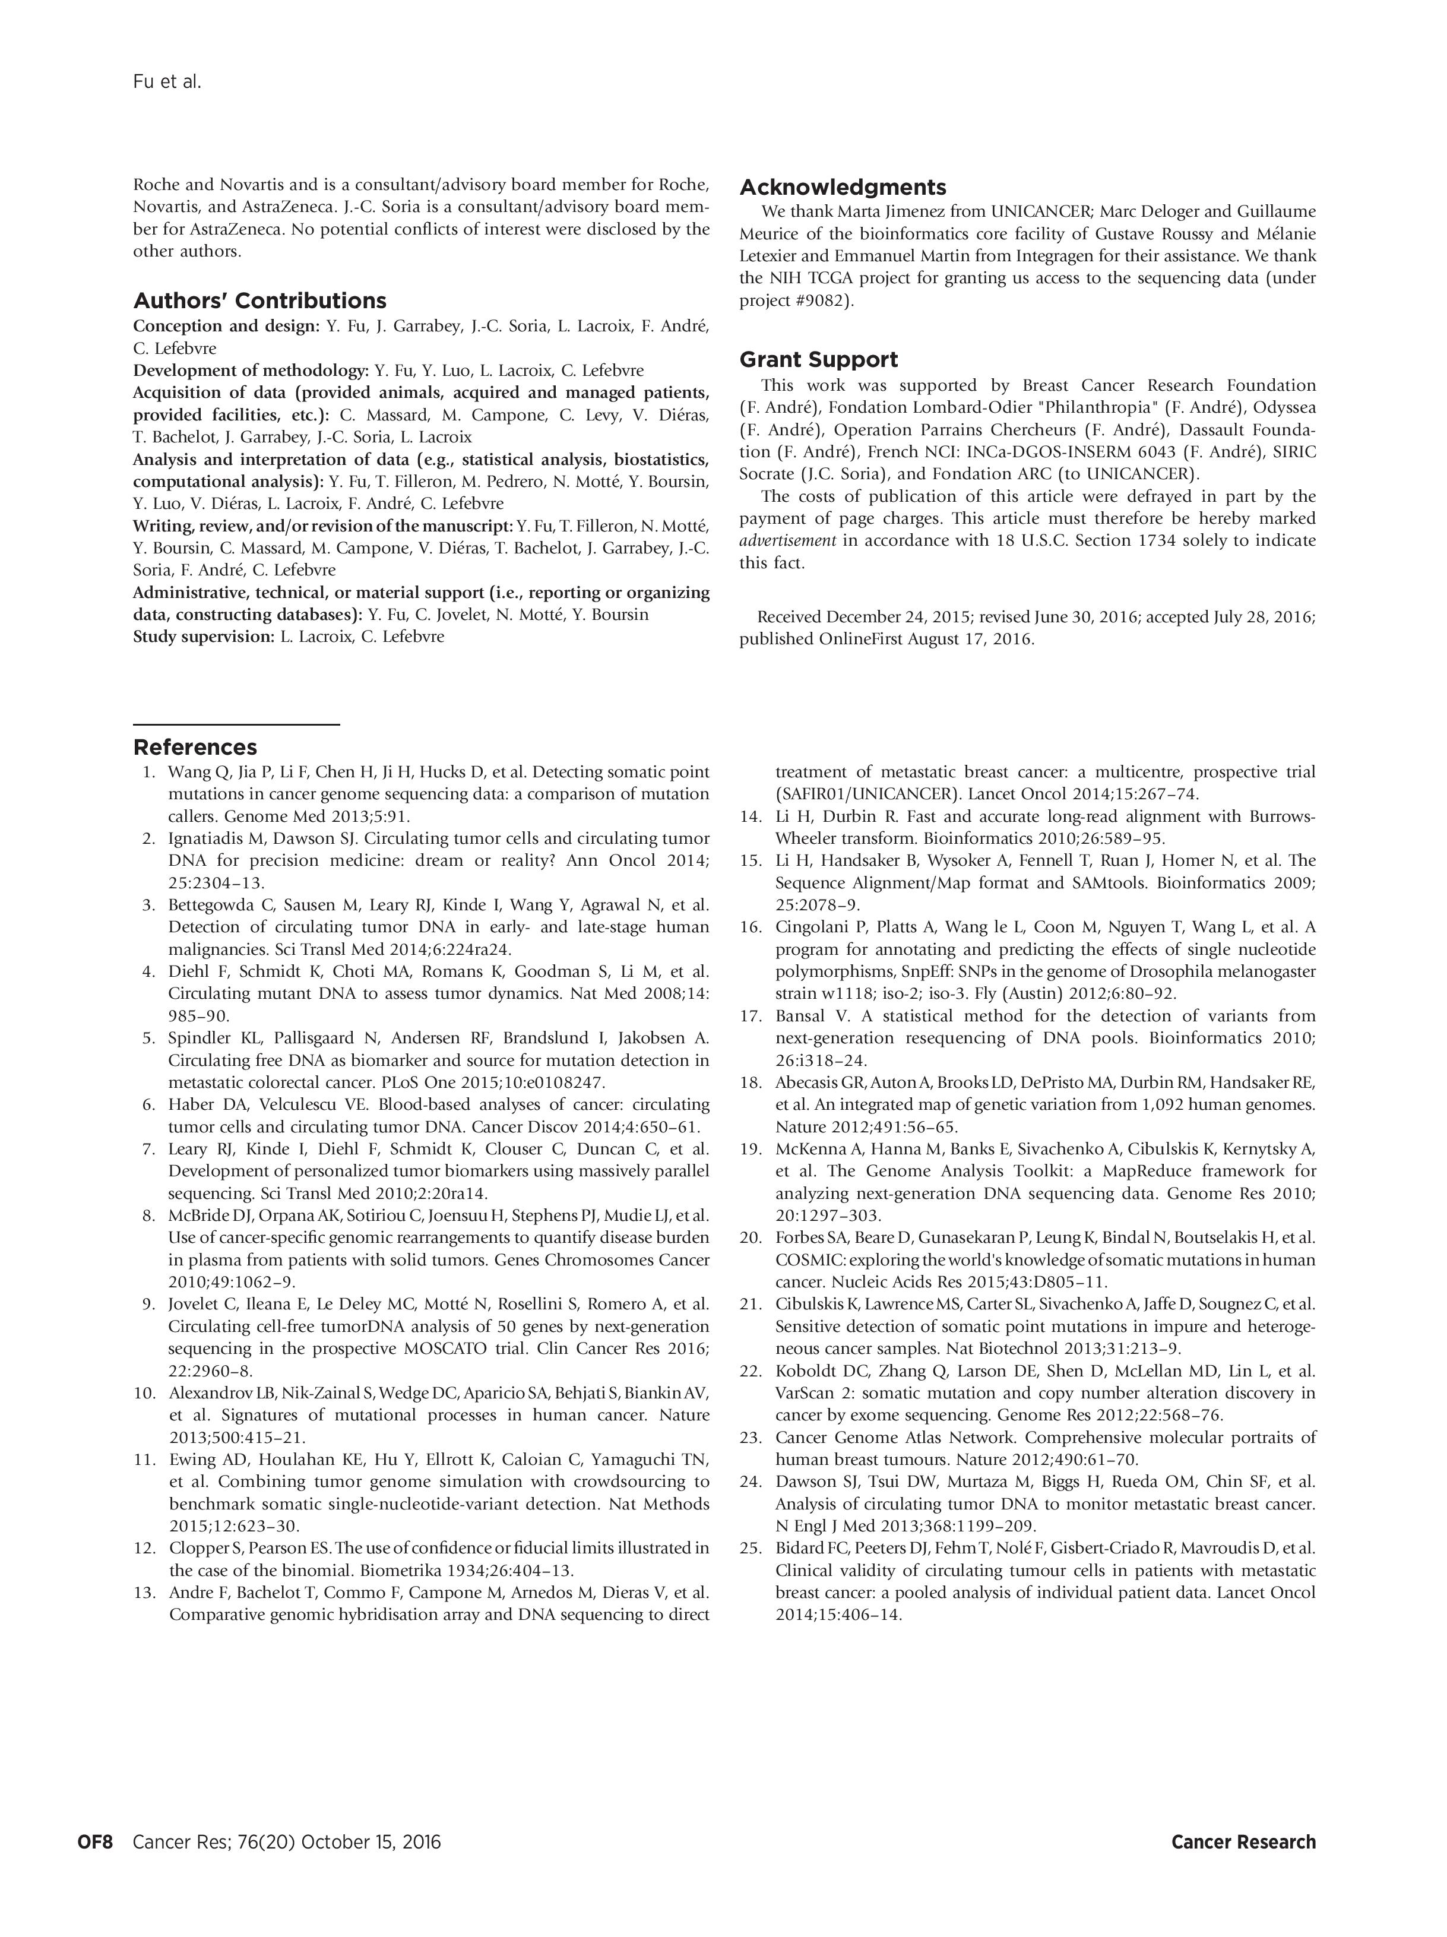

### The use of cmDetect in small cohorts

In order to improve mutation calling accuracy for advanced cancer patients, we developed a method to be applied as a complementary tool to traditional somatic mutation callers in the presence of ctDNA in patients’ whole blood. Somatic mutation identification is an important step in personalized medicine because of its direct implication on patients’ prognostic. We showed the essential need of applying cmDetect in the context of ctDNA contamination of the whole blood sample used as source of germline DNA, especially for patients with metastatic cancer. However, cmDetect is not suitable for analyzing a small cohort of patients (ex N<10) mainly due to two reasons.

First, cmDetect estimates a sequencing bias rate (error rate) based on the total observations at a given position. As the sequencing techniques are well mastered, the sequencing error rate is expected to be quite low (for Illumina Hiseq machine, 96% of the total reads have a base quality score of more than 30, which means 1 error read out of 1000). For example, in a cohort of 10 patients sequenced at 100X (a total of 1,000 reads at each position), only one read with sequence error can be observed at a given position considering a sequencing error rate of 0.1%, and any lower rate is impossible to estimate. Second, a cohort specific Minor allele frequency (MAF) is needed for filtering polymorphisms as the polymorphisms documented in dbSNP may not be sufficient as they are estimated based one the general population and might not be representative in a specific cohort of patients. Again, a small set of patients is not suitable for this estimation (ex: a variant observed in one patient out of ten gives a MAF=10%, which is more likely due to chance than a correct statistical estimation). We therefore recommend using cmDetect with caution in the case of small patient cohorts.

A possible solution in the case of ctDNA contamination in a small cohort of patients is to collect a set of sequencing data generated under the same protocol with the same machine for the estimation of sequencing bias and uses this estimation in the cmDetect pipeline. Another solution to avoid the contamination of ctDNA in the blood sample is to remove the plasma that contains circulating DNA from the whole blood sample before sequencing.

## Integrated analysis of genomic and pharmacological data to better predict anti-cancer drug response

### Co-existing alterations of different pathways are related to drug resistance

Precision medicine trials in oncology evaluate the benefit of a therapeutic strategy based on a molecular profile identifying point mutations and/or genomic rearrangements harbored by the tumor cells of the patient. However, the decision-making is usually based on the identification of singular actionable aberrations and remains suboptimal. If multiple targets are identified in the tumor, the rules governing the selection of the optimal target for treatment are usually nonexistent. In this work, we investigated the effect of the presence of multiple actionable targets in tumor cells on their response to single-target treatments.

We used pharmacogenomics data from GDSC and CCLE to study the drug response to targeted therapies in cell lines carrying multiple alterations as compared to cell lines with a single alteration focusing on a subset of 7 groups of targeted therapies and 29 gene targets (Figure 19). The 7 groups of targeted therapies were selected as they have been assessed by the 2 cell line projects (GDSC and CCLE) and for their use in clinical practice. The 29 gene targets are the direct targets of the 7 groups of targeted therapies and their upstream genes, up to 2 levels of regulation, in the same pathway. For example, RAS, RAF and MEK were defined as the targets of anti-MEK inhibitors.

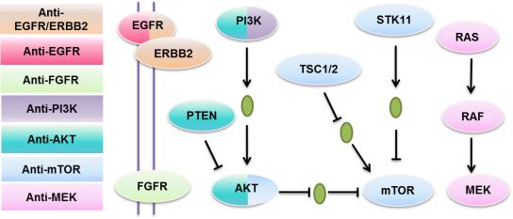

Figure . Inhibitors and pathways selected for the study. Genes are defined as target/targets of the inhibitor of the same color. For example, RAS, RAF and MEK are targets of anti-MEK inhibitors.

We studied the drug response to targeted therapies in the 3 groups defined as: “One alteration” cell lines, “Multiple alterations” cell lines and “Wild type” cell lines. “One alteration” cell lines are the cell lines carrying only alteration of one target among the 7 groups of targeted genes; “Multiple alterations” cell lines are the cell lines carrying not only alteration in the group of targeted gene but also in at least one other group of target gene; “Wild type” cell lines are cell lines not carrying any alteration in the gene targets of the study. For example, to an anti-EGFR inhibitor, cell lines with an amplification of EGFR and wild type of the rest of the 28 gene targets are classified in the “One alteration” group; cell lines with a mutation of EGFR and a mutation of PIK3CA are in the “Multiple alterations” and cell lines without any alteration of these 29 genes are in the “Wild type” group (Figure 20).

﻿The measurement of the cell line response to drugs is defined by the normalized area under the drug response curve (nAUC) or the half maximal inhibitory concentration (IC50). Here we define an alteration in a gene as the presence of a mutation or a copy number strictly greater than 4 (amplification) or lower than 2 (loss)(Table 2). We selected a list of 126 drug-gene-alteration pairs for 19 drugs and 29 targetable genes and classified the cell lines according to the number of alterations in these 29 genes.

|  |
| --- |
| Figure . Classification of cell lines according to the mutational status of 29 genes. |

|  |
| --- |
| Table . Data information from two public cell lines databases and patients used in the study. |

The comparison of the drug response in these 3 groups () demonstrated that cell lines carrying only alterations in the targets of the drug are more sensitive than cell lines carrying alterations in the targets of the drug plus alterations in at least one group of other targetable gene (, Wilcoxon signed-rank test, p = *3e-30* for GDSC and Wilcoxon signed-rank test, p = *4e-3* for CCLE)

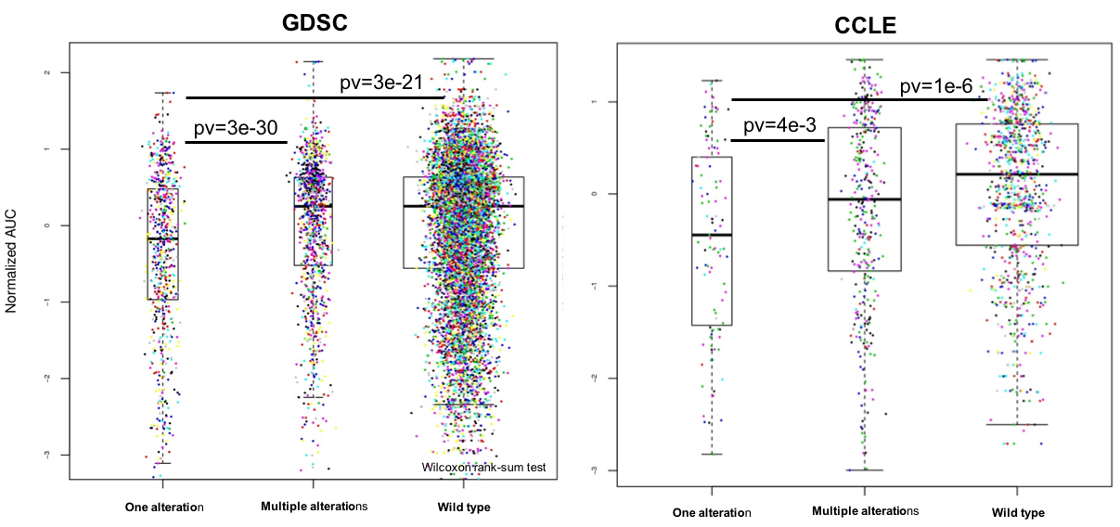

Figure . Cell lines with co-existing alterations of multiple targetable genes are more resistant to treatments than those with an alteration in one targetable gene only.

To extend this finding, we were interested in the details about the “plus alteration” and wanted to test if alterations in different pathways generate different levels of resistance. We further investigated the impact of each pathway as a second alteration on drug resistance in cell lines. We split the group “Multiple alterations” into 7 subgroups according to the second pathway altered, not-targeted by the drug of interest. By comparing the drug response of these subgroups, we showed that different pathways have different impact on drug response (; ANOVA, p= 6.42x10-6). In particular, pathway MEK and pathway AKT have the most significant impact on drug resistance (Wilcoxon signed-rank test, p = 1.9x10-10 and p= 2.9x10-5 respectively).

|  |
| --- |
| Figure . Effect on the drug response of an alteration in a non-targeted pathway. |

We then examined clinical data from the MOSCATO clinical trial at Gustave Roussy (MOlecular Screening for CAncer Treatment Optimization) to validate these findings for cancer patients treated with targeted therapies matching an alteration of their tumor. MOSCATO is a clinical trial where genomic characterization of cancer patients’ tumor is investigated in order to direct the patients to a suitable targeted therapy. Genomic and clinical data for 95 patients that have received one of the 7 types of targeted therapies were retrieved. Mutation status (whole exome sequencing and targeted sequencing) and copy number variations (CGH array) were available for all these patients (Jovelet, et al. 2016). As patients in the MOSCATO clinical trial receive targeted therapies when the matching targetable genes are identified as altered, the “wild type” group does not exist. The patients were classified into “One alteration” group if they presented an alteration only in the actionable target of their corresponding treatment and “Multiple alterations” group if they also presented alterations in the actionable targets of another drug from .

|  |
| --- |
| Table . List of targeted therapies from the MOSCATO trial considered in the analysis. |

We performed a log-rank test to evaluate the difference of overall survival between the “One alteration” group and the “Multiple alterations” group (R package “survival”). The results showed that the patients in the “One alteration” group had a better overall survival rate as compared to the patients in the “Multiple alterations” group (log-rank test p-value: 0.038, ). However, the total number of mutations was not found to be associated with the survival as a continuous variable (Cox proportional-hazards regression model, likelihood ratio test p-value=0.92). These results demonstrated that, as observed in the cell lines, the number of targetable alterations in a tumor is an important factor to consider when selecting a drug treatment for a cancer patient and may affect overall survival.

|  |
| --- |
| Figure . Overall survival comparison of MOSCATO patients treated with a therapy targeting an alteration of their tumor. The 2 groups were built according to the number of targetable alterations the tumor harbored, only 1 alteration (the targeted alteration, group in red, N=56) and >1 alteration (the targeted alteration + another targetable alteration, group in green, N=39). |

#### Conclusion

We have shown in this section that the co-existence of alterations of different pathways have an impact on drug response, both in cell lines and patients. These results demonstrated the limitation of the therapeutic decision-making based on the identification of singular actionable aberrations of a tumor and the potential risk of drug resistance. Therefore, more complex decision roles/prediction algorithms are needed when multiple targets are identified. We then developed an integrated predictive mode to identify more complex patterns of prediction.

### An integrated predictive model to identify predictive biomarkers

#### Regenerating drug response using gene expression data

One study has compared the data available in GDSC and CCLE and has shown an inconsistency in the drug response data for the drugs and cell lines shared by the two large-scale cell line datasets (Haibe-Kains, et al. 2013). They have shown that while the genomic data, especially the gene expression data, of the shared cell lines was highly correlated; the drug response data of the 15 common drugs () was poorly correlated. The inconsistency of the drug response in the two data sets could be a result of different drug screenings and measuring methods. Meanwhile numerous studies have shown that gene expression data is one of the most accurate data set to predict drug response in cell lines and in patients (Geeleher, Cox, and Huang 2014; Dong, et al. 2015; Costello, et al. 2014).

|  |
| --- |
| Table . Drugs in common between GDSC and CCLE |

In order to select predictive biomarkers accurately, we need to overcome the inconsistency problem between the two data sets as well as the problem of a high number of missing values in the drug response data. To this end, we used the gene expression data of the 2,000 genes with the highest variance as predictors to regenerate the drug response (AUC) for each cell line and each drug. As one of our goals is to identify biomarkers related to the sensitivity or resistance to anti-cancer drugs, the continuous drug response data was also transformed into to 3 categories based on their data statistic ():

* Sensitive: AUC < mean(AUC) – sd(AUC);
* Resistant: AUC > mean(AUC) + sd(AUC);
* Intermediate: other.

(sd = standard deviation)

|  |
| --- |
| Figure . Distribution of the drug response of cell lines and transformation of continuous data to categorical (data from GDSC). |

Four popular machine learning methods namely Elastic net (Zou and Hastie 2005), Support Vector Machine (SVM, Steinwart and Christmann 2008), Random Forest (RF, Breiman 2001) and Adaboost (Freund and Schapire 1999) were tested for the prediction model. The machine learning algorithms were performed using R packages (Elastic net: ‘glmnet’, Random Forest: ‘RamdomForest’, SVM: ‘e1071’, Adaboost: ‘ada’) and the parameters were tuned using 10-time cross validation.

|  |
| --- |
| Figure . The consistency of drug response between GDSC and CCLE were improved by generating new drug response using gene expression data |

As shown in , the consistency of the drug response for cell lines was improved between the two data sets for the predicted drug response using gene expression data. We then used the new drug response generated by SVM, Elastic Net, Adaboost and RF and a set of genomic alterations as predictors in a Random Forest model to identify predictive biomarkers. Only mutations and copy number variations were included as predictors in the Random Forest model in order to generate “easy to use and interpret” treatment decision guiding rules. We observed that adding a step of predicting the drug response data using elastic net improved the random forest model for the identification of direct targets of the inhibitors as predictors of the response of the corresponding drug, as compared to SVM, RF, Adaboost and the original drug response for both GDSC and CCLE database ().

|  |
| --- |
| Table . More direct drug targets were identified by Random Forest using drug response generated by the predictive models and gene expression data. Elastic Net outperformed the others. A red case represents that the direct target of the inhibitor in row was correctly identified by the method in column in both GDSC and CCLE. |

Finally, we designed an integrated predictive model to identify predictive biomarkers with 2 steps. The first step of the model is to predict the drug response of the cell lines using an Elastic net model with the expression data of 2,000 genes with the highest variance. Parameters of elastic net were tuned using 10-times cross validation. The second step of the model is to identify predictive biomarkers using Random Forest. Each predictor in the Random Forest model was evaluated with an associated importance calculated based on two methods. One method is to calculate an accuracy drop of the drug response prediction averaged on the ensemble of trees while permuting the predictor’s value randomly. The other method is to calculate the gain of purity (for categorical data) or the decrease of variance (for continuous data) based on the variable chosen to split the node. A p-value associated to each importance was also calculated using a 1,000-time permutation of the drug response to evaluate predictor-drug response relationship independently, p values are corrected using False Discovery Rate (FDR) ().

|  |
| --- |
| Figure . An integrated predictive model to identify predictive biomarkers. A first step of regenerating drug response using elastic net model and gene expression data and a second step of identifying predictive biomarkers using random forest model combine with 1000-time permutation of the drug response. |

To identify predictive biomarkers for a larger set of drugs, we focused our efforts on GDSC in which more drugs were available. We applied this model to a set of 111 targeted therapies and confirmed that using reassessed drug response in the Random Forest model improves its ability to identify direct targets of the targeted therapies (). We also observed that models using continuous drug response data performed better than those using categorical drug response data, probably due to the information loss while transforming the continuous data to categorical. We decided therefore to focus the further analyses on continuous drug response data.

|  |
| --- |
| Figure . The use of regenerated drug response improved the identification of the direct target of drugs using random forest for a set of 111 targeted therapies available in GDSC. Each column represents a targeted therapy; each row represents a condition, for example, “newic50_0.05 55.04%” means using new drug response generated by elastic net, 55.04% of the direct target of the total 111 drugs are identified by random forest at significance of 0.05. top: continuous drug response data, bottom: categorical drug response data. |

As expected, we also identified known predictive biomarkers other than the direct target. For example, mutations of KRAS were identified as a predictive biomarker for resistance to the anti-AKT drug AZD5363 while mutations of PTEN where predictive biomarkers for sensitivity to AZD5363 () (Davies, et al. 2012).

|  |
| --- |
| Figure . : Cell lines with muted KRAS are more resistant to AZD5363 than cell lines with wild type KRAS (left). Cell lines with PTEN mutation are more sensitive to AZD5363 than cell lines with wild type PTEN (right). |

To further investigate the additive predictive power of these two predictors, we built a predictive tree model and observed that the cell lines with KRAS mutation and PTEN wild type are the most resistant subgroup of cells to AZD5363 (). When combining the two predictors of resistance together (PTEN wild type and KRAS mutation are biomarkers of resistance to AZD5363), we were able to identify the most resistance subgroup of cells, which indicate the potential of combining multiple biomarkers to better predict the drug response.

|  |
| --- |
| Figure . cell lines are classified into different subgroups based on their mutational status of 3 genes. Each node is marked by the mean drug response to AZD5363 and the number of cell lines in the node. Cell lines that are mutated in KRAS but not mutated in PTEN are the more resistant to AZD5363, an anti-AKT inhibitor than the rest of cell lines. |

In another example, we identified the mutation of NOTCH1 as the most predictive alterations (p-value=0.003, FDR=0.026) associated to the response to AZD8055, an anti-mTOR inhibitor. The cells with NOTCH1 mutations were significantly more resistant to the drug than cells with wild type NOTCH1 (Figure 30). NOTCH1 gene encodes a class I transmembrane protein functioning as a ligand-activated transcription factor, which plays an important role in a number of cellular functions. NOTCH1 has been considered as an oncogene in several lymphoid malignancies, but recent evidence has also suggested that Notch signaling could be a tumor suppressor in myeloid malignancies (Lobry, et al. 2014). One study has shown that NOTCH1 knockdown reduced the level of mechanistic target of rapamycin (mTOR) protein in the monoblastic leukemia cell line (Okuhashi, et al. 2013). The reason why cell lines with NOTCH1 mutations are more resistant to AZD8055 is still not clear, further *in vitro* studies are needed to better understand the underlying mechanistic explanation.

|  |
| --- |
| Figure . The cells with NOTCH1 mutations are significantly more resistant to AZD8055, an anti-mTOR inhibitor, than cells with normal NOTCH1. |

CDKN2A mutations (p-value=0.004, FDR=0.033) and CDKN2A amplification (p-value=0.001, FDR=0.008) were identified as top predictors for JW7521, another anti-mTOR inhibitor. CDKN2A mutation was identified as predictive of sensitivity to JW7521 while amplification of CDKN2A was identified as predictive of resistance to JW7521. We hypothesized that the activation of CDKN2A is predictive of the drug response to JW752 and examined the drug response between cell lines with CDKN2A inactivation (cell lines with the inactivating mutation or/and with a deletion) and cell lines with CDKN2A activation (cell lines without the mutation but an amplification). We showed that cell lines that are CDKN2A activated were significantly more resistant to JW7521 than cell lines that were CDKN2A inactivated (Figure 31). CDKN2A, frequently mutated or deleted in cancer, is a protein coding gene coding for tumor suppressors p16 and p14arf (McWilliams, et al. 2011). One study has shown that inactivating mutations of CDKN2A result in elevated mTORC1/2 signaling (Souroullas and Sharpless 2015) and this might offer an explanation for identifying the cell lines with inactivated CDKN2A as more sensitive to an anti-mTOR inhibitor.

|  |
| --- |
| Figure . Cell lines that are CDKN2A activated (defined as cell lines with an amplification and not mutated) were significantly more resistant to JW7521 than cell lines that were CDKN2A inactivated (defined as cell lines with a mutation or/and a deletion). |

The deletion of PHLPP2 was identified to be associated with drug response to CI-1040, an anti-MEK inhibitor (). PHLPP2 is an important regulator of AKT serine-threonine kinases, which inactive AKT1 and AKT3 by dephosphorylation (Brognard, et al. 2007). A loss of PHLPP2 in the cells could lead to increased activity of AKT and ERK pathways, which promote cell survival.

|  |
| --- |
| Figure . Cells with PHLPP2 deletion are significantly more resistant to CCI-1040, an anti-MEK inhibitor than cells with no deletion of PHLPP2. |

#### 

#### Conclusion

In this part, we developed a 2-step predictive model that combines an Elastic net model to impute and adjust the drug response using gene expression data, and a Random Forest model to identify predictive biomarkers. We first showed that our model has better capacity of identifying the direct targets of the targeted therapies as compared to other models tested. We then used our model to identify new biomarkers that have never been identified. Some evidence was found in the literature to support these finding which makes these biomarkers good candidates to further investigation for drug target development.

### Evaluating combination of predictive biomarkers using Random Forest

Although many studies have shown the feasibility and efficiency in identifying biomarkers with mathematical models combined with high throughput genomic data, there are still some unresolved issues. One for instance is that most models identify single biomarkers. Even for models that take into consideration the correlated genomic features such as elastic net, the relevance of these features to the outcome to predict is still evaluated separately. Although biomarkers based on single gene alteration are the most commonly used in clinical applications today, driver events can be due to a combination of multiple alterations given the complexity of cancer biology. It is therefore necessary to identify combinations of predictive biomarkers, which paired with multiple targeted therapies have the potential to play important roles as biomarkers in the future.

In order to identify combination of predictors, we developed a method to evaluate the importance of coupled predictors in Random Forest thanks to the structure of the tree predictors.

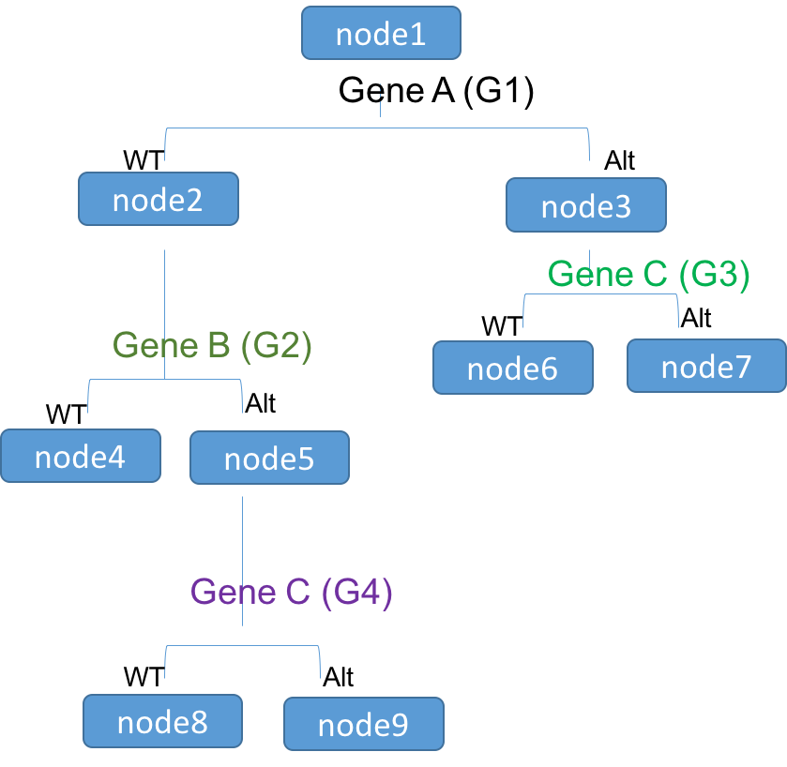

Figure . A decision tree model with binary predictors.

The tree model we used in Random forest framework is illustrated in , where the parent nodes are split into daughter nodes based on the status of the selected genomic alterations. For example, the node1 is split into node2 and node3 based on the status of the gene A (with a gain of purity of G1), then the node3 is split into node6 and node7 based on the status of gene C (with a gain of purity of G3). If this pattern (gene C is always chosen to split the node while the parent node contains only altered gene A) is observed repeatedly in the ensemble of tree, we assume that there is a predictive power of the combination of gene A and gene C.

To evaluate the predictive power of all the paired predictors in a Random Forest algorithm, we made a modification based in the R package “RamdomForest” implementation to output not only the predictor to split but also the predictor used to generate the parent node to split as shown in .

|  |
| --- |
| Figure . Matrix for evaluating predictors in combination. |

We calculated the importance of paired predictors for a set of 19 targeted therapies of 7 targets () and identified combinations of predictors.

Table . List of drugs for which combinations of predictive biomarkers were evaluated.

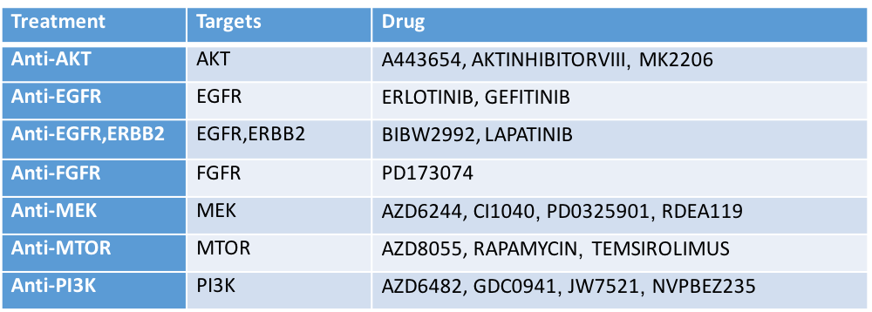

For example, the top 6 combinations of predictive biomarkers for AKT inhibitor VIII, an anti-AKT inhibitor, are shown in . We observed that cell lines with mutation of PIK3CA were more sensitive than the wild type cell lines (p-value= 1.78e-6) while cell lines with FGF5 deletion had similar drug respond than cell lines with no deletion of FGF5. Surprisingly, the combination of PIK3CA mutation and FGF5 deletion in cell lines leaded to drug resistance (p-value=0.09) while none of these two predictors in isolation showed such an effect ().

|  |
| --- |
| Figure . Left: top 6 combinations of predictive biomarkers identified for ATK inhibitor VIII (p-value<0.005), an anti-AKT inhibitor. Right: Drug response to AKT inhibitor VIII of cell lines based on their mutational status of PIK3CA and copy number of FGF5. Boxes from the left to right represent the drug response of cell lines: PIK3CA mutated, FGF5 deleted, PIK3CA wild type and FGF5 not deleted, PIK3CA wild type and FGF5 deleted, PIK3CA mutated and FGF5 not deleted, PIK3CA mutated and FGF5 deleted. |

We showed that the co-existence of PIK3CA mutation and FGF5 deletion is predictive to resistance to ATK inhibitor VIII. Clinical evidence suggested that patients with PIK3CA-mutant tumors might benefit from treatment with Akt inhibitors (U, et al. 2013), Our results, that need to be validated, suggested that the alteration status of FGF5 should be verified before giving an anti-AKT inhibitor to patients with PIK3CA mutation.

Combinations of predictive biomarkers were also identified for CI1040, an anti-MEK inhibitor (Figure 36). We observed that cells with both BRAF mutation and FGF9 deletion showed significant resistance to CI1040 (p-value=0.04) while cells with BRAF mutation alone were sensitive (p-value=3.5e-13) and cells with FGF9 deletion alone showed no predictive effect (p-value=0.93). Similar results were observed for BRAF mutation and PIK3CG mutation, cells with both BRAF mutation and PIK3CG mutation showed significant resistance to CI1040 (p-value=0.04) while cells with BRAF mutation alone were sensitive (p-value=2.8e-13) and cells with PIK3CG mutation alone showed no difference in drug response compared to WT cells (p-value=0.55).

|  |
| --- |
| Figure . Top: top 12 predictive combinations of biomarkers identified for CI1040, an anti-MEK inhibitor; bottom left: cells with the combination of BRAF mutation and FGF9 deletion showed significant resistance to CI1040 while cells with BRAF mutation alone were sensitive and cells with FGF9 deletion alone showed no difference in drug response compared to WT cells; bottom right: cells with BRAF mutation and PIK3CG mutation are more resistant than the other cells. |

For AZD8055, an anti-mTOR inhibitor, combinations of biomarkers predictive of sensitivity and of resistance were identified. Cell lines with both NRAS mutation and CDKN2A mutation were more sensitive to AZD8055 than cell lines that had neither NRAS mutation nor CDKN2A mutation (p-value=0.01, , top right); cell lines with BRCA2 amplification and KRAS mutation were more resistant to AZD8055 than cells with neither BRCA2 amplification nor KRAS mutation (p-value=0.004, , bottom left); the combination of FGF9 amplification and KRAS mutation was significantly associated to drug resistance to AZD8055 (p-value=0.0006, , bottom right).

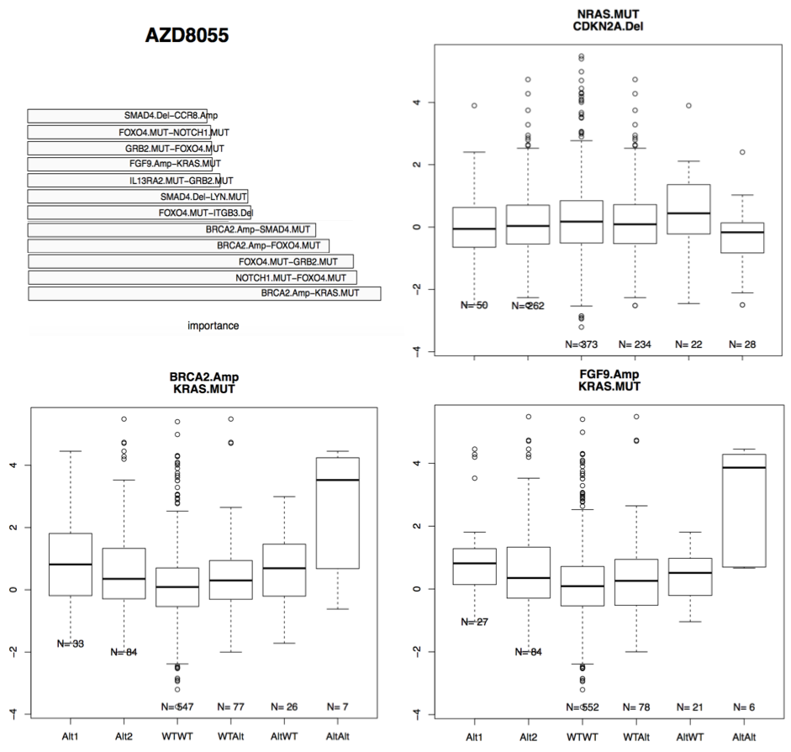

Figure . Top left: Top 12 predictive biomarkers identified for AZD8055, an anti-mTOR inhibitor; top right: cells with the combination of NRAS mutation and CDKN2A are more sensitive to AZD8055 than other cells; bottom left: cells with BRCA2 amplification and KRAS mutation are more resistant than the other cells; bottom right: cells with FGF deletion and KRAS mutation are more resistant than the other cells.

The combination of CDKN2A mutation with either the deletion of SMAD4 (p-value=0.001) or MAP3K7 (p-value=0.002) was identified as predictive to the resistance of cell lines to TEMSIROLIMUS, an anti-mTOR inhibitor (, top left and top right). Interestingly, SMAD4 and MAP3K7 are not located in the same region of the genome (SMAD4 is located at 18q21.2 while MAP3K7 is located at 6q15), but are both involved in the MAPK pathway ( bottom), suggesting that CDKN2A mutation combined with alteration of the MAPK pathway could lead to drug resistance to TEMSIROLIMUS.

|  |
| --- |
| Figure . The combinations of CDKN2A mutation of both SMAD4 deletion and MAP3K7 deletion were predictive to drug resistance of cell lines to TEMSIROLIMUS, an anti-mTOR inhibitor; the gene SMAD4 and MAK3K7 are both involve in the MAPK pathway indicating that the alteration of the pathway MAPK combined with an CDKN2A mutation has some impact on the drug response of cell lines to TEMSIROLIMUS (from KEGG). |

#### Conclusion

In this part, we developed a method to evaluate the predictive power of combinations of predictors based on Random Forest model. To our knowledge, this is the first method to select combinations of predictors instead of single ones. The identification of predictive combinations of predictors has an important implication in the study of drug resistance. It can help us better understand the mechanisms of drug resistance and eventually prevent it by identifying complex genomic patterns that are predictive of specific targeted therapy response.

# Discussion

In this thesis, we discussed mainly two mathematical and informatics applications in the context of personalized medicine for cancer patients.

The first application is cmDetect, a method that we propose to use as a complementary tool to traditional somatic mutation callers to recover false negatives due to ctDNA contamination of the germline DNA extracted from whole blood using whole exome sequencing data. We validated the accuracy of cmDetect with both simulated data and patients’ data. By addressing this issue, we not only demonstrated that ctDNA is detectable in sequencing data of whole blood DNA and has an impact on somatic mutation identification, but also the importance of the accurate identification of somatic mutations that may have a direct impact on treatment decision in the context of personalized medicine for cancer patients.

The second application is a mathematical model to identify predictive biomarkers of targeted therapies drug response. We first showed that co-existing alterations in multiple driver genes could cause drug resistance in both cell lines and patients. We then identified single as well as combinations of predictive biomarkers for a set of targeted therapies using cell line data. The identified biomarkers were supported by statistical tests but further *in vitro* and *in vivo* validation is still needed. We offered an effective method for identifying complex predictive patterns of targeted therapies in a systematic manner, which gives an insight of the underlying biological mechanism of drug response. The predictive biomarkers identified could not only guide further research for identifying new targets to targeted therapies in preclinical studies, but also help designing better cancer clinical trials.

There are still some issues to address in order to improve the predictive models:

## Further validation is needed for the biomarker identified

We have shown that co-existing alterations in multiple driver genes can lead to drug resistance and validated the results in a cohort of cancer patients in the MOSCATO clinical trial. *In vitro* validation is still needed to better understand the underlying explanation of such an observation. This is also true for the predictions of the single and combined predictive biomarkers identified in our 2-step model.

## Genomic data of real tumors is needed to build the predictive model

Cell lines are useful tools for characterizing genomic profiles of cancer cells and measuring cancer cell drug response to a large set of drugs but the gap between cell lines and real tumors is not negligible. One of the reasons is that tumors are heterogeneous and often formed of multiple sub clones of different genetic backgrounds. As cell lines are derived from one cancer cell, they do not capture the global picture of the tumor. Under the selection pressure of a targeted therapy, a sub clone of cancer cells with a driver mutation in a gene other than the target of the drug can develop rapidly and lead to the drug resistance of the tumor. This type of acquired drug resistance cannot be observed in cell lines thus cannot be learned by a predictive model built using cell lines data. Although a large number of patients’ sequencing data is available in datasets such as TCGA, the clinical response of these patients are often under chemotherapies but not targeted therapies because these patients are mostly with primary cancer. The clinical trials where the cancer patients are treated with targeted therapies based on their genomic profile such as SAFIR01, SAFIR02 and MOSCATO, offer us a unique opportunity to study cancer genomics in advanced cancer patients.

## The p>>n problem in the predictive model

The p>>n problem refers to a problem in predictive or regression models where the number of predictors is much bigger than the number of samples. Genomic data usually contains hundreds or even thousands of genes that are used as predictors while the number of available samples is often small (ex: 20,000 genes vs 1,000 cell lines). Although random forest used in our 2-step predictive model has been shown to have a relative good performance in making prediction and identifying predictors facing p>>n problem, methods of reducing predictor dimension can still be helpful. Many methods have been proposed for such purpose such as principal component analysis (Jolliffe 1986), factor analysis (Cattell 1952) and feature selection such as embedded.

## Multitask predictive model

Given the fact that some drugs target the same gene and ought to have similar effect in cell lines, multi-task models can be used to improve predictive performance as compared to learning models separately. Multi-task model is a machine learning method that learns multiple models together by sharing the information in order to improve predictive accuracy. For example, Bayesian multitask multiple kernel learning (MKL, (Gönen and Alpaydin 2011)) has been used for drug response prediction using gene expression data of cell lines and outperformed all the other methods in a collective drug response prediction challenge (Costello, et al. 2014). We can also combine multi-task method with random forest to build multi-task random forest models (Simm, Abril, and Sugiyama 2014; Haider, et al. 2015; Yao, Yang, and Zhan 2013), which have shown good performance in predictive modeling.

# Annex

## Supplementary data—cmDetect

### Filter patient specific polymorphism

Most of the mutations identified in the tumor sample and in the normal sample are either germline mutations or polymorphisms. To filter out these mutations that are not caused by ctDNA contamination, we used 3 methods shown in . We first hypothesized that a germline mutation would have comparable allele frequency in the tumor sample and the normal sample and removed all the mutations with a non-significant difference of allele frequency between the tumor and the normal sample (p-value > 0.01). We then compute the MAF based on our cohort of patients in the analysis and removed all the mutations with a MAF > 0.01. Finally, we generated, for each patient, a distribution of the allele frequency in the normal sample of all the heterozygous mutations and removed the mutations with a high probably of being a heterozygous mutation in the normal sample.

|  |
| --- |
| Figure . Methods to filter out polymorphisms. |

### Filter false positives from the pool of blood samples

As the quantity of ctDNA in the whole blood sample is small, it is difficult to distinguish a variant due to ctDNA contamination from a sequencing bias (sequencing error). Here we hypothesized that a variant caused by sequencing bias has an equal probability to occur in all the samples sequenced by the same method while a variant caused by ctDNA contamination will only be present in the patients where the same variant in detected in their tumor. Therefore, we computed the p-value that a given variant identified in the blood sample is a true ctDNA mutation using a one sided binomial test ().

|  |
| --- |
| Figure . Filter false positives using the pool of blood samples. |

### Simulation data for cmDetect performance evaluation

To evaluate the performance of cmDetect combined with traditional somatic mutation callers, we built a set of simulated tumor/normal whole exome sequencing data using real sequencing data from 1000 Genomes data set as shown in . Whole exome sequencing data of individuals from phase 3 with an average of coverage of 80-200 were retrieved. In order to implement Bamsurgeon (Ewing, et al. 2015) to simulate tumor sequencing data, we remapped the data to the reference genome hg19 using samtools (Li, et al. 2009) and bwa (Li and Durbin 2010). A set of somatic mutations and small insertions and deletions were then retrieved from COSMIC data set, only mutations that have been identified in more than 2 samples were used. Bamsurgeon was used to insert the preselected mutations and indels into the whole exome sequencing data of normal individuals to simulate tumor samples. Contaminated whole blood sequencing samples were generated using Samtools by mixing randomly the reads from the normal sample and the simulated tumor sample at a random rate.

|  |
| --- |
| Figure . Data simulation for cmDetect performance evaluation. |
|  |

# Reference

Ai, B., et al. 2016. "Circulating Cell-Free Dna as a Prognostic and Predictive Biomarker in Non-Small Cell Lung Cancer." *Oncotarget* (Jun). <http://dx.doi.org/10.18632/oncotarget.10069>.

Alexandrov, L. B., et al. 2013. "Signatures of Mutational Processes in Human Cancer." *Nature* 500, no. 7463 (Aug): 415-21. <http://dx.doi.org/10.1038/nature12477>.

Andrews, Simon. 2014. *Fastqc: A Quality Control Tool for High Throughput Sequence Data.*: <http://www.bioinformatics.babraham.ac.uk/projects/fastqc>.

André, F., et al. 2014. "Comparative Genomic Hybridisation Array and Dna Sequencing to Direct Treatment of Metastatic Breast Cancer: A Multicentre, Prospective Trial (Safir01/Unicancer)." *Lancet Oncol* 15, no. 3 (Mar): 267-74. <http://dx.doi.org/10.1016/S1470-2045(13)70611-9>.

Ascierto, P. A., et al. 2012. "The Role of Braf V600 Mutation in Melanoma." *J Transl Med* 10 (Jul): 85. <http://dx.doi.org/10.1186/1479-5876-10-85>.

Barretina, J., et al. 2012. "The Cancer Cell Line Encyclopedia Enables Predictive Modelling of Anticancer Drug Sensitivity." *Nature* 483, no. 7391 (Mar): 603-7. <http://dx.doi.org/10.1038/nature11003>.

Baylin, S. B. 2005. "Dna Methylation and Gene Silencing in Cancer." *Nat Clin Pract Oncol* 2 Suppl 1 (Dec): S4-11. <http://dx.doi.org/10.1038/ncponc0354>.

Bean, J., et al. 2008. "Acquired Resistance to Epidermal Growth Factor Receptor Kinase Inhibitors Associated with a Novel T854a Mutation in a Patient with Egfr-Mutant Lung Adenocarcinoma." *Clin Cancer Res* 14, no. 22 (Nov): 7519-25. <http://dx.doi.org/10.1158/1078-0432.CCR-08-0151>.

Ben-Yaacov, E., and Y. C. Eldar. 2008. "A Fast and Flexible Method for the Segmentation of Acgh Data." *Bioinformatics* 24, no. 16 (Aug): i139-45. <http://dx.doi.org/10.1093/bioinformatics/btn272>.

Biankin, A. V., S. Piantadosi, and S. J. Hollingsworth. 2015. "Patient-Centric Trials for Therapeutic Development in Precision Oncology." *Nature* 526, no. 7573 (Oct): 361-70. <http://dx.doi.org/10.1038/nature15819>.

Bienkowska, J. R., et al. 2009. "Convergent Random Forest Predictor: Methodology for Predicting Drug Response from Genome-Scale Data Applied to Anti-Tnf Response." *Genomics* 94, no. 6 (Dec): 423-32. <http://dx.doi.org/10.1016/j.ygeno.2009.08.008>.

Bird, A. 2002. "Dna Methylation Patterns and Epigenetic Memory." *Genes Dev* 16, no. 1 (Jan): 6-21. <http://dx.doi.org/10.1101/gad.947102>.

Bolger, A. M., M. Lohse, and B. Usadel. 2014. "Trimmomatic: A Flexible Trimmer for Illumina Sequence Data." *Bioinformatics* 30, no. 15 (Aug): 2114-20. <http://dx.doi.org/10.1093/bioinformatics/btu170>.

Boveri, T. 1914. *Zur Frage Der Entstehung Maligner Tumoren .* Gustav Fischer.

Boveri, T. 2008. "Concerning the Origin of Malignant Tumours by Theodor Boveri. Translated and Annotated by Henry Harris." *J Cell Sci* 121 Suppl 1 (Jan): 1-84. <http://dx.doi.org/10.1242/jcs.025742>.

Breiman, L. 2001. *Random Forests*. Vol. **45** (1): 5–32.doi:10.1023/A:1010933404324. *Machine Learning*.

Brognard, J., et al. 2007. "Phlpp and a Second Isoform, Phlpp2, Differentially Attenuate the Amplitude of Akt Signaling by Regulating Distinct Akt Isoforms." *Mol Cell* 25, no. 6 (Mar): 917-31. <http://dx.doi.org/10.1016/j.molcel.2007.02.017>.

Burris, H. A. 2001. "Docetaxel (Taxotere) Plus Trastuzumab (Herceptin) in Breast Cancer." *Semin Oncol* 28, no. 1 Suppl 3 (Feb): 38-44.

Cattell, R. B. 1952. *Factor Analysis*: Harper.

Chan, B. A., and B. G. Hughes. 2015. "Targeted Therapy for Non-Small Cell Lung Cancer: Current Standards and the Promise of the Future." *Transl Lung Cancer Res* 4, no. 1 (Feb): 36-54. <http://dx.doi.org/10.3978/j.issn.2218-6751.2014.05.01>.

Charles Ferté, Christophe Massard, Ecaterina Ileana, Antoine Hollebecque, Ludovic Lacroix, Samy Ammari, Maud Ngo-Camus, Rastislav Bahleda, Anas Gazzah, Andrea Varga,Sophie Postel-Vinay, Yohann Loriot, Nathalie Auger, Valerie Koubi-Pick, Bastien Job, Thierry De Baere, Frederic Deschamps, Philippe Vielh, Vladimir Lazar, Marie-Cécile Le Deley, Catherine Richon, vincent ribrag, eric deutsch, eric angevin, gilles vassal, Alexander Eggermont, Fabrice André and Jean-Charles Soria. 2014. *Abstract Ct240: Molecular Screening for Cancer Treatment Optimization (Moscato 01): A Prospective Molecular Triage Trial; Interim Analysis of 420 Patients*. **DOI:** 10.1158/1538-7445.AM2014-CT240 ed.

Chen, K., et al. 2007. "Methylation of Multiple Genes as Diagnostic and Therapeutic Markers in Primary Head and Neck Squamous Cell Carcinoma." *Arch Otolaryngol Head Neck Surg* 133, no. 11 (Nov): 1131-8. <http://dx.doi.org/10.1001/archotol.133.11.1131>.

Chen, Z., et al. 2005. "Crucial Role of P53-Dependent Cellular Senescence in Suppression of Pten-Deficient Tumorigenesis." *Nature* 436, no. 7051 (Aug): 725-30. <http://dx.doi.org/10.1038/nature03918>.

Cheng, F., L. Su, and C. Qian. 2016. "Circulating Tumor Dna: A Promising Biomarker in the Liquid Biopsy of Cancer." *Oncotarget* (May). <http://dx.doi.org/10.18632/oncotarget.9453>.

Cibulskis, K., et al. 2013. "Sensitive Detection of Somatic Point Mutations in Impure and Heterogeneous Cancer Samples." *Nat Biotechnol* 31, no. 3 (Mar): 213-9. <http://dx.doi.org/10.1038/nbt.2514>.

Costello, J. C., et al. 2014. "A Community Effort to Assess and Improve Drug Sensitivity Prediction Algorithms." *Nat Biotechnol* 32, no. 12 (Dec): 1202-12. <http://dx.doi.org/10.1038/nbt.2877>.

Dai, M., et al. 2010. "Ngsqc: Cross-Platform Quality Analysis Pipeline for Deep Sequencing Data." *BMC Genomics* 11 Suppl 4: S7. <http://dx.doi.org/10.1186/1471-2164-11-S4-S7>.

Davies, B. R., et al. 2012. "Preclinical Pharmacology of Azd5363, an Inhibitor of Akt: Pharmacodynamics, Antitumor Activity, and Correlation of Monotherapy Activity with Genetic Background." *Mol Cancer Ther* 11, no. 4 (Apr): 873-87. <http://dx.doi.org/10.1158/1535-7163.MCT-11-0824-T>.

Dees, N. D., et al. 2012. "Music: Identifying Mutational Significance in Cancer Genomes." *Genome Res* 22, no. 8 (Aug): 1589-98. <http://dx.doi.org/10.1101/gr.134635.111>.

Despierre, E., et al. 2014. "Somatic Copy Number Alterations Predict Response to Platinum Therapy in Epithelial Ovarian Cancer." *Gynecol Oncol* 135, no. 3 (Dec): 415-22. <http://dx.doi.org/10.1016/j.ygyno.2014.09.014>.

Dettling, M., and P. Bühlmann. 2003. "Boosting for Tumor Classification with Gene Expression Data." *Bioinformatics* 19, no. 9 (Jun): 1061-9.

Dong, Z., et al. 2015. "Anticancer Drug Sensitivity Prediction in Cell Lines from Baseline Gene Expression through Recursive Feature Selection." *BMC Cancer* 15: 489. <http://dx.doi.org/10.1186/s12885-015-1492-6>.

Drake, J. W., et al. 1998. "Rates of Spontaneous Mutation." *Genetics* 148, no. 4 (Apr): 1667-86.

Ewing, A. D., et al. 2015. "Combining Tumor Genome Simulation with Crowdsourcing to Benchmark Somatic Single-Nucleotide-Variant Detection." *Nat Methods* 12, no. 7 (Jul): 623-30. <http://dx.doi.org/10.1038/nmeth.3407>.

Flaherty, K. T., et al. 2012. "Improved Survival with Mek Inhibition in Braf-Mutated Melanoma." *N Engl J Med* 367, no. 2 (Jul): 107-14. <http://dx.doi.org/10.1056/NEJMoa1203421>.

Freund, Yoav, and Robert E. Schapire. 1999. *A Short Introduction to Boosting*. Vol. 14(5):771-780: Journal of Japanese Society for Artificial Intelligence.

Gambacorti-Passerini, C., and R. Piazza. 2015. "Imatinib--a New Tyrosine Kinase Inhibitor for First-Line Treatment of Chronic Myeloid Leukemia in 2015." *JAMA Oncol* 1, no. 2 (May): 143-4. <http://dx.doi.org/10.1001/jamaoncol.2015.50>.

Garnett, M. J., et al. 2012. "Systematic Identification of Genomic Markers of Drug Sensitivity in Cancer Cells." *Nature* 483, no. 7391 (Mar): 570-5. <http://dx.doi.org/10.1038/nature11005>.

Geeleher, P., N. J. Cox, and R. S. Huang. 2014. "Clinical Drug Response Can Be Predicted Using Baseline Gene Expression Levels and in Vitro Drug Sensitivity in Cell Lines." *Genome Biol* 15, no. 3: R47. <http://dx.doi.org/10.1186/gb-2014-15-3-r47>.

Gordon, L. I. 2016. "Precision Monitoring by Next-Generation Sequencing in Lymphoma: Circulating Tumor Dna as a New Biomarker." *Oncology (Williston Park)* 30, no. 8 (Aug).

Griffiths AJF, Gelbart WM, Miller JH. 1999. *Chromosomal Rearrangements*. New York: W. H. Freeman: Modern Genetic Analysis.

Gönen, M., and E. Alpaydin. 2011.*Multiple Kernel Learning Algorithms*. 12 vols.: Mach. Learn. Res.

Haibe-Kains, B., et al. 2013. "Inconsistency in Large Pharmacogenomic Studies." *Nature* 504, no. 7480 (Dec): 389-93. <http://dx.doi.org/10.1038/nature12831>.

Haider, S., et al. 2015. "A Copula Based Approach for Design of Multivariate Random Forests for Drug Sensitivity Prediction." *PLoS One* 10, no. 12: e0144490. <http://dx.doi.org/10.1371/journal.pone.0144490>.

HOWARD, B. D., and I. TESSMAN. 1964. "Identification of the Altered Bases in Mutated Single-Stranded Dna. Ii. In Vivo Mutagenesis by 5-Bromodeoxyuridine and 2-Aminopurine." *J Mol Biol* 9 (Aug): 364-71.

Hupé, P., et al. 2004. "Analysis of Array Cgh Data: From Signal Ratio to Gain and Loss of Dna Regions." *Bioinformatics* 20, no. 18 (Dec): 3413-22. <http://dx.doi.org/10.1093/bioinformatics/bth418>.

Hutchison, C. A. 2007. "Dna Sequencing: Bench to Bedside and Beyond." *Nucleic Acids Res* 35, no. 18: 6227-37. <http://dx.doi.org/10.1093/nar/gkm688>.

Jokinen, E., and J. P. Koivunen. 2015. "Mek and Pi3k Inhibition in Solid Tumors: Rationale and Evidence to Date." *Ther Adv Med Oncol* 7, no. 3 (May): 170-80. <http://dx.doi.org/10.1177/1758834015571111>.

Jolliffe, I.T. 1986. *A Tutorial on Principal Components Analysis*: Springer-Verlag.

Jovelet, C., et al. 2016. "Circulating Cell-Free Tumor Dna Analysis of 50 Genes by Next-Generation Sequencing in the Prospective Moscato Trial." *Clin Cancer Res* 22, no. 12 (Jun): 2960-8. <http://dx.doi.org/10.1158/1078-0432.CCR-15-2470>.

Kaelin, W. G. 2005. "The Concept of Synthetic Lethality in the Context of Anticancer Therapy." *Nat Rev Cancer* 5, no. 9 (Sep): 689-98. <http://dx.doi.org/10.1038/nrc1691>.

Kandoth, C., et al. 2013. "Mutational Landscape and Significance across 12 Major Cancer Types." *Nature* 502, no. 7471 (Oct): 333-9. <http://dx.doi.org/10.1038/nature12634>.

Kim, D., et al. 2013. "Tophat2: Accurate Alignment of Transcriptomes in the Presence of Insertions, Deletions and Gene Fusions." *Genome Biol* 14, no. 4: R36. <http://dx.doi.org/10.1186/gb-2013-14-4-r36>.

Koboldt, D. C., et al. 2012. "Varscan 2: Somatic Mutation and Copy Number Alteration Discovery in Cancer by Exome Sequencing." *Genome Res* 22, no. 3 (Mar): 568-76. <http://dx.doi.org/10.1101/gr.129684.111>.

Larkin, J., et al. 2014. "Combined Vemurafenib and Cobimetinib in Braf-Mutated Melanoma." *N Engl J Med* 371, no. 20 (Nov): 1867-76. <http://dx.doi.org/10.1056/NEJMoa1408868>.

Leary, R. J., et al. 2008. "Integrated Analysis of Homozygous Deletions, Focal Amplifications, and Sequence Alterations in Breast and Colorectal Cancers." *Proc Natl Acad Sci U S A* 105, no. 42 (Oct): 16224-9. <http://dx.doi.org/10.1073/pnas.0808041105>.

Li, H., and R. Durbin. 2010. "Fast and Accurate Long-Read Alignment with Burrows-Wheeler Transform." *Bioinformatics* 26, no. 5 (Mar): 589-95. <http://dx.doi.org/10.1093/bioinformatics/btp698>.

Li, H., et al. 2009. "The Sequence Alignment/Map Format and Samtools." *Bioinformatics* 25, no. 16 (Aug): 2078-9. <http://dx.doi.org/10.1093/bioinformatics/btp352>.

Lobry, C., et al. 2014. "Notch Signaling: Switching an Oncogene to a Tumor Suppressor." *Blood* 123, no. 16 (Apr): 2451-9. <http://dx.doi.org/10.1182/blood-2013-08-355818>.

Lovly, C., L. Horn, W. Pao. 2016. *Molecular Profiling of Lung Cancer*: *My Cancer Genome* <https://www.mycancergenome.org/content/disease/lung-cancer/>

Maemondo, M., et al. 2010. "Gefitinib or Chemotherapy for Non-Small-Cell Lung Cancer with Mutated Egfr." *N Engl J Med* 362, no. 25 (Jun): 2380-8. <http://dx.doi.org/10.1056/NEJMoa0909530>.

Maher, C. A., et al. 2009. "Transcriptome Sequencing to Detect Gene Fusions in Cancer." *Nature* 458, no. 7234 (Mar): 97-101. <http://dx.doi.org/10.1038/nature07638>.

Marguerat, S., and J. Bähler. 2010. "Rna-Seq: From Technology to Biology." *Cell Mol Life Sci* 67, no. 4 (Feb): 569-79. <http://dx.doi.org/10.1007/s00018-009-0180-6>.

Marioni, J. C., N. P. Thorne, and S. Tavaré. 2006. "Biohmm: A Heterogeneous Hidden Markov Model for Segmenting Array Cgh Data." *Bioinformatics* 22, no. 9 (May): 1144-6. <http://dx.doi.org/10.1093/bioinformatics/btl089>.

Marx, Vivien. 2014. *Cancer Genomes: Discerning Drivers from Passengers*. **11** vols.: Nature Methods.

Masters, J. R. 2000. "Human Cancer Cell Lines: Fact and Fantasy." *Nat Rev Mol Cell Biol* 1, no. 3 (Dec): 233-6. <http://dx.doi.org/10.1038/35043102>.

McCarroll, S. A., and D. M. Altshuler. 2007. "Copy-Number Variation and Association Studies of Human Disease." *Nat Genet* 39, no. 7 Suppl (Jul): S37-42. <http://dx.doi.org/10.1038/ng2080>.

McDermott, U., and J. Settleman. 2009. "Personalized Cancer Therapy with Selective Kinase Inhibitors: An Emerging Paradigm in Medical Oncology." *J Clin Oncol* 27, no. 33 (Nov): 5650-9. <http://dx.doi.org/10.1200/JCO.2009.22.9054>.

McWilliams, R. R., et al. 2011. "Prevalence of Cdkn2a Mutations in Pancreatic Cancer Patients: Implications for Genetic Counseling." *Eur J Hum Genet* 19, no. 4 (Apr): 472-8. <http://dx.doi.org/10.1038/ejhg.2010.198>.

Myers, C. L., C. Chiriac, and O. G. Troyanskaya. 2009. "Discovering Biological Networks from Diverse Functional Genomic Data." *Methods Mol Biol* 563: 157-75. <http://dx.doi.org/10.1007/978-1-60761-175-2_9>.

Nicolas Goossens, Shigeki Nakagawa, Xiaochen Sun and Yujin Hoshida. 2015. *Cancer Biomarker Discovery and Validation*: Transl Cancer Res. 2015 Jun; 4(3): 256–269.

Okuhashi, Y., et al. 2013. "Notch Knockdown Affects the Proliferation and Mtor Signaling of Leukemia Cells." *Anticancer Res* 33, no. 10 (Oct): 4293-8.

Olshen, A. B., et al. 2004. "Circular Binary Segmentation for the Analysis of Array-Based Dna Copy Number Data." *Biostatistics* 5, no. 4 (Oct): 557-72. <http://dx.doi.org/10.1093/biostatistics/kxh008>.

Raphael, B. J., et al. 2014. "Identifying Driver Mutations in Sequenced Cancer Genomes: Computational Approaches to Enable Precision Medicine." *Genome Med* 6, no. 1: 5. <http://dx.doi.org/10.1186/gm524>.

Redon, R., and N. P. Carter. 2009. "Comparative Genomic Hybridization: Microarray Design and Data Interpretation." *Methods Mol Biol* 529: 37-49. <http://dx.doi.org/10.1007/978-1-59745-538-1_3>.

Reva, B., Y. Antipin, and C. Sander. 2011. "Predicting the Functional Impact of Protein Mutations: Application to Cancer Genomics." *Nucleic Acids Res* 39, no. 17 (Sep): e118. <http://dx.doi.org/10.1093/nar/gkr407>.

Riddick, G., et al. 2011. "Predicting in Vitro Drug Sensitivity Using Random Forests." *Bioinformatics* 27, no. 2 (Jan): 220-4. <http://dx.doi.org/10.1093/bioinformatics/btq628>.

Rios, J., and S. Puhalla. 2011. "Parp Inhibitors in Breast Cancer: Brca and Beyond." *Oncology (Williston Park)* 25, no. 11 (Oct): 1014-25.

Robert, C., et al. 2015. "Nivolumab in Previously Untreated Melanoma without Braf Mutation." *N Engl J Med* 372, no. 4 (Jan): 320-30. <http://dx.doi.org/10.1056/NEJMoa1412082>.

Rodrik-Outmezguine, V. S., et al. 2016. "Overcoming Mtor Resistance Mutations with a New-Generation Mtor Inhibitor." *Nature* 534, no. 7606 (Jun): 272-6. <http://dx.doi.org/10.1038/nature17963>.

Rosell, R., et al. 2012. "Erlotinib Versus Standard Chemotherapy as First-Line Treatment for European Patients with Advanced Egfr Mutation-Positive Non-Small-Cell Lung Cancer (Eurtac): A Multicentre, Open-Label, Randomised Phase 3 Trial." *Lancet Oncol* 13, no. 3 (Mar): 239-46. <http://dx.doi.org/10.1016/S1470-2045(11)70393-X>.

Salesse, S., and C. M. Verfaillie. 2002. "Bcr/Abl: From Molecular Mechanisms of Leukemia Induction to Treatment of Chronic Myelogenous Leukemia." *Oncogene* 21, no. 56 (Dec): 8547-59. <http://dx.doi.org/10.1038/sj.onc.1206082>.

Schwarzenbach, H., D. S. Hoon, and K. Pantel. 2011. "Cell-Free Nucleic Acids as Biomarkers in Cancer Patients." *Nat Rev Cancer* 11, no. 6 (Jun): 426-37. <http://dx.doi.org/10.1038/nrc3066>.

Schwarzenbach, H., and K. Pantel. 2015. "Circulating Dna as Biomarker in Breast Cancer." *Breast Cancer Res* 17, no. 1: 136. <http://dx.doi.org/10.1186/s13058-015-0645-5>.

Segal, E., H. Wang, and D. Koller. 2003. "Discovering Molecular Pathways from Protein Interaction and Gene Expression Data." *Bioinformatics* 19 Suppl 1: i264-71.

Shah, N. M., et al. 2013. "Understanding the Role of Nrf2-Regulated Mirnas in Human Malignancies." *Oncotarget* 4, no. 8 (Aug): 1130-42. <http://dx.doi.org/10.18632/oncotarget.1181>.

Sharma, S. V., et al. 2007. "Epidermal Growth Factor Receptor Mutations in Lung Cancer." *Nat Rev Cancer* 7, no. 3 (Mar): 169-81. <http://dx.doi.org/10.1038/nrc2088>.

Sim, N. L., et al. 2012. "Sift Web Server: Predicting Effects of Amino Acid Substitutions on Proteins." *Nucleic Acids Res* 40, no. Web Server issue (Jul): W452-7. <http://dx.doi.org/10.1093/nar/gks539>.

Simm, Jaak, Ildefons Magrans de Abril, and Masashi Sugiyama. 2014. *Tree-Based Ensemble Multi-Task Learning Method*

*for Classification and Regression*. Vol. E97-D. 6 vols.: IEICE Transactions on Information and Systems.

Slamon, D. J., et al. 1987. "Human Breast Cancer: Correlation of Relapse and Survival with Amplification of the Her-2/Neu Oncogene." *Science* 235, no. 4785 (Jan): 177-82.

Sosman, J. A., et al. 2012. "Survival in Braf V600-Mutant Advanced Melanoma Treated with Vemurafenib." *N Engl J Med* 366, no. 8 (Feb): 707-14. <http://dx.doi.org/10.1056/NEJMoa1112302>.

Sotiriou, C., et al. 2003. "Breast Cancer Classification and Prognosis Based on Gene Expression Profiles from a Population-Based Study." *Proc Natl Acad Sci U S A* 100, no. 18 (Sep): 10393-8. <http://dx.doi.org/10.1073/pnas.1732912100>.

Souroullas, G. P., and N. E. Sharpless. 2015. "Mtor Signaling in Melanoma: Oncogene-Induced Pseudo-Senescence?" *Cancer Cell* 27, no. 1 (Jan): 3-5. <http://dx.doi.org/10.1016/j.ccell.2014.12.005>.

Steinwart, Ingo, and Andreas Christmann. 2008. *Support Vector Machines*: Springer Publishing Company, Incorporated.

Stetson, L. C., et al. 2014. "Computational Identification of Multi-Omic Correlates of Anticancer Therapeutic Response." *BMC Genomics* 15 Suppl 7: S2. <http://dx.doi.org/10.1186/1471-2164-15-S7-S2>.

Stewart, E. L., et al. 2015. "Known and Putative Mechanisms of Resistance to Egfr Targeted Therapies in Nsclc Patients with Egfr Mutations-a Review." *Transl Lung Cancer Res* 4, no. 1 (Feb): 67-81. <http://dx.doi.org/10.3978/j.issn.2218-6751.2014.11.06>.

Sørlie, T., et al. 2001. "Gene Expression Patterns of Breast Carcinomas Distinguish Tumor Subclasses with Clinical Implications." *Proc Natl Acad Sci U S A* 98, no. 19 (Sep): 10869-74. <http://dx.doi.org/10.1073/pnas.191367098>.

Templeton, A. J., et al. 2013. "Phase 2 Trial of Single-Agent Everolimus in Chemotherapy-Naive Patients with Castration-Resistant Prostate Cancer (Sakk 08/08)." *Eur Urol* 64, no. 1 (Jul): 150-8. <http://dx.doi.org/10.1016/j.eururo.2013.03.040>.

Trela, E., S. Glowacki, and J. Błasiak. 2014. "Therapy of Chronic Myeloid Leukemia: Twilight of the Imatinib Era?" *ISRN Oncol* 2014: 596483. <http://dx.doi.org/10.1155/2014/596483>.

U, Banerji, et al. 2013. *Results of Two Phase I Multicenter Trials of Azd5363, an Inhibitor of Akt1, 2 and 3: Biomarker and Early Clinical Evaluation in Western and Japanese Patients with Advanced Solid Tumors.* Vol. 73:abstr LB-66.: Cancer Res.

van der Vaart, M., and P. J. Pretorius. 2007. "The Origin of Circulating Free Dna." *Clin Chem* 53, no. 12 (Dec): 2215. <http://dx.doi.org/10.1373/clinchem.2007.092734>.

Venter, J. C., H. O. Smith, and M. D. Adams. 2015. "The Sequence of the Human Genome." *Clin Chem* 61, no. 9 (Sep): 1207-8. <http://dx.doi.org/10.1373/clinchem.2014.237016>.

Vermeulen, L., and H. J. Snippert. 2014. "Stem Cell Dynamics in Homeostasis and Cancer of the Intestine." *Nat Rev Cancer* 14, no. 7 (Jul): 468-80. <http://dx.doi.org/10.1038/nrc3744>.

von Hansemann, D. 1890. *Ueber Asymmetrische Zelltheilung in Epithel Krebsen Und Deren Biologische Bedeutung .* Vol. 119: Virchows Arch. Path. Anat.

Wang, Z., M. Gerstein, and M. Snyder. 2009. "Rna-Seq: A Revolutionary Tool for Transcriptomics." *Nat Rev Genet* 10, no. 1 (Jan): 57-63. <http://dx.doi.org/10.1038/nrg2484>.

WATSON, J. D., and F. H. CRICK. 1953. "Molecular Structure of Nucleic Acids; a Structure for Deoxyribose Nucleic Acid." *Nature* 171, no. 4356 (Apr): 737-8.

Yao, Dengju, Jing Yang, and Xiaojuan Zhan. 2013. *A Novel Method for Disease Prediction: Hybrid*

*of Random Forest and Multivariate Adaptive*

*Regression Splines*. Vol. 8. 1 vols.: JOURNAL OF COMPUTERS.

Yasuda, H., S. Kobayashi, and D. B. Costa. 2012. "Egfr Exon 20 Insertion Mutations in Non-Small-Cell Lung Cancer: Preclinical Data and Clinical Implications." *Lancet Oncol* 13, no. 1 (Jan): e23-31. <http://dx.doi.org/10.1016/S1470-2045(11)70129-2>.

Zou, H, and T Hastie. 2005. *Regularization and Variable Selection Via the Elastic Net*: J. R. Statist. Soc. B (2005).

# 